ENVIRONMENTAL ASSESSMENT REPORT

construction of 3-storied BETAGI Poura SUPER market
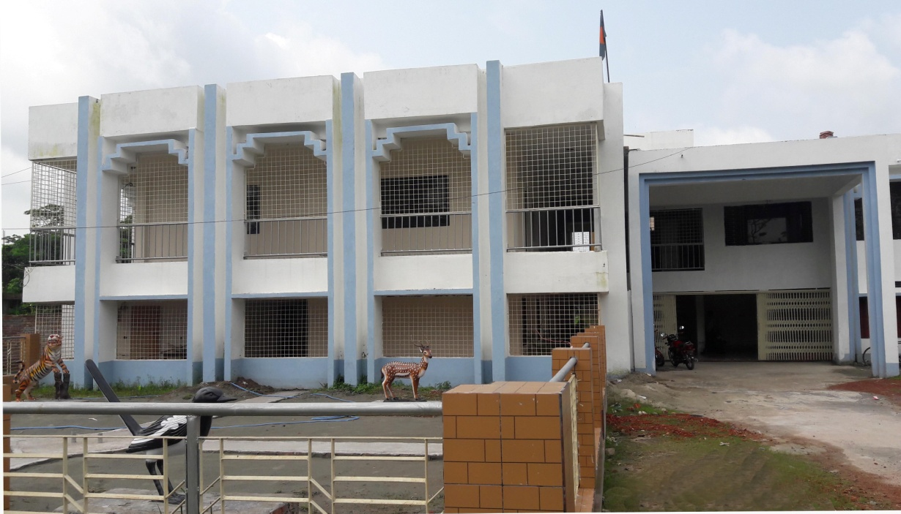
Municipal Governance and Services Project (MGSP)
Bangladesh Municipal Development Fund (BMDF)
September 2018
betagi pourashava, bARGUNA
Prepared By
………………………..
………………………….
………………………….

Supported By
Md. Jasim Uddin
Assistant Engineer
Betagi Pourashava, Barguna

Guided By
ABM Golam Kabir
Mayor
Betagi Pourashava, Barguna

Period of Conducting the Study: September 2018

Disclaimer
This Environmental Assessment Report is prepared by the own fund of the Betagi Pourashava to fulfill the requirements of Bangladesh Municipal Development Fund (BMDF) in seeking the financial support for the “Construction of 3-storied Betagi Poura Super Market” under its Municipal Governance and Services Project (MGSP).

EXECUTIVE SUMMARY
Introduction: BetagiPourashava is a Class “B” Pourashava having an area of 10.75sq km. The total area of the Pourashava is divided into 9 administrative wards with a total population of 10204 (BBS, 2011). Recently, the Pourashava has prepared its Capital Investment Plan (CIP) for its infrastructural development following a participatory approach with the technical assistance from Bangladesh Municipal Development Fund (BMDF) and identified “Construction of 3-storied Betagi Super Market” as one of the priority works (CIP No. 01) for meeting the demand of space for shops, enhancing the opportunity of selling and buying daily household goods from both wholesale and retail shops at one point, creating the job and business opportunity young people and traders, and increasing the generation of revenue of Pourashava for its sustainability. The proposed Super Market is situated at the south side of the Pourashava and 1 km far from the Pourashava Bhaban. The estimated cost of the subproject is BDT 25 million and the duration of construction is 12 months starting in November 2018 and to be ended by October 2019.
Location of the subproject:The proposed subproject is located at Betagi Bazar area under the Ward No. 07 of Betagi Pourashava. It is located at the Betagi Bazar area well connected to the Bazar Road and Betagi launch Terminal. It is surrounded by shops at the north and the south; roads at the east and west side. The project site of the market is 1 km far from the Poura Bhaban of Betagi Pourashava. The coordinate of the location of the Poura Super Market is 22°25'02.1" N and 90°09'53.5" E.
Justification of selecting the subproject: The Capital Investment Plan (CIP) 2018-2022 of Betagi Pourashava listed a number of subprojects and identified the construction of proposed Super Market as the priority among the potential markets considering its location, demand of space for accommodating wholesale and retail shops, scope of creating job opportunities and scope of revenue generation of the Pourashava. The Betagi area, where the proposed Super Market is situated, is the bazar area of Betagi Pourashava near to the Betagi Launch Terminal and Bazar road. However, the present capacity of the markets in the area is not sufficient to meet the present demand of the area as well as of the Pourashava. In addition, the increasing population of the Pourashava has been demanding more household goods. Considering reasonably the increasing demand and absence of any well-designed super market, the Pourashava felt needs of an improved super market which will be very helpful to the urban dwellers, local producers and traders. Moreover, this market as the permanent sources of revenue will increase the volume of revenue of the Pourashava. In all of these necessities, a well-designed super market with required facilities is very much justified and essential for the Pourashava. In fact, with the establishment of the proposed subproject will provide a well structural, customer, operational and environment friendly easy trading and shopping facilities for both male and female buyers and sellers in all the year round. In addition, the proposed subproject site is owned by the Pourashava and no need to acquire additional land for constructing the multi-storied building with all modern facilities for a super market. Moreover, it will create business opportunity for many businessmen and create jobs for workers and salesmen, thus helps to increase income and earnings for livelihood of local people. It will also create the revenue generation avenue for the Pourashava and will help the Pourashava in attaining the sustainability of the institution.
Objective of the study: As per the environmental management framework (EMF) of MGSP, BMDF, it is required to conduct an environmental assessment of the proposed Super Market in accordance with the legal regulatory framework of the Government of Bangladesh and the World Bank policies. The general objective of the study is to determine the major environmental impacts that might be happened due to the implementation of the subproject and to recommend possible mitigation measures to avoid or reduce identified adverse environmental impacts and to enhance positive impacts. The specific objectives include:
- Identifying existing environment condition at the sub-project areas for environmental components viz. air, noise, water, land, soil, biological and socio-economic aspects;
- Prediction and evaluation of positive and negative impacts that may result from the proposed sub-project;
- Undertaking public consultation and disclosure of project-related information;
- Formulation of an environmental management plan (EMP) to eliminate or minimize the adverse impacts of the project on the surrounding environment and affected communities;
- Preparing occupational health and safety to minimize any accident or emergency situation;
- Proposing plans for the post project monitoring, ongoing consultation and disclosure, EMP implementation, and institutional arrangement/organizational arrangement; and
- Suggestion and recommendation for abatement/mitigation/management measures to ensure environmental, biological, health and social compatibilities and also to comply with the National Environmental legal requirements and national Environmental Quality standards.
Methodology of the study: This is a qualitative study. However, both quantitative and qualitative data are collected and analyzed to achieve the objective of the study and show the baseline information of the study areas. Quantitative data are collected from secondary sources and qualitative data are collected from primary sources using different qualitative approach and methods. The approach and methods those are applied during the assessment include: (i) Consultation with stakeholders and community people; (ii) Focus Group Discussion; and (iii) Field visit and observation.
Findings of environmental impact assessment: The environmental screening, field observation and community consultation have identified that the proposed super market has insignificant ecological, physiochemical and biological impacts on the environment but has positive impact of social environment. There is no need to fell down trees and clearing vegetation as the structure will be developed at the place of existing tin shed. The market may have temporary and localized negative impact on physicochemical environment during construction and operational phases due to movement of vehicles and using of different machines. It is anticipated that the air pollution and water logging will be insignificant due to taking necessary measures and existing drainage system. The noise pollution may have moderate level of impact due to use of mixture machine, drilling machine, vibrator, carrying of construction materials etc which can be minimized by using proper silencer and mufflers in all categories of machineries. In addition, the physical, cultural and archeological impact will be insignificant. There is only a temple apart from the proposed market which is well-protected by a boundary wall. The subproject might have negative socio-economic impact due to traffic congestion and health and safety issues of workers and laborers during construction phase. However, it has a positive impact on the local and regional economy due to generation of employment opportunity and will facilitate the trade and business of the people living in the different parts of the.
Conclusion and recommendations: On the basis of the findings of the environmental assessment, it could be concluded that the subproject is environmentally sound and sustainable. The potential environmental impacts seem very minimum and manageable, and it would be minimized by taking proposed mitigation measures. The Government of Bangladesh and World Bank have some legal and social safeguard compliances issues those are applicable during constructing and operating the proposed subproject. Considering the issues and findings of the study, following key recommendations are made for smooth construction and successful operation of the market:
- Separate parking lot for private cars and goods carrying trucks should be established by the municipality maintaining a considerable distance from the market to avoid traffic congestion at the market area.
- A well-defined solid waste collection and disposal system should be in place at the market.
- All waste water should be discharged to a soak pit which will need to be constructed for the proposed market.
- the Municipal drainage system. In the absence of such system in the vicinity of the market, the septic tanks should be constructed.
- Fire prevention and fighting equipment should be provided and maintained as well as market management committee should be trained in fire prevention and fighting.
- The market should have facilities for washing, prayer, toilet, waiting, shopping, meals and snacks.
- Contractor will ensure availability of the PPEs and first-aid box, water supply and sanitation facilities to the workers.
- The surrounding people should be informed about the construction and operation of the Super market.
- Above all, the EMP should be followed and mitigation measures should be monitored as per EMP.

TABLE OF CONTENTS
EXECUTIVE SUMMARY ii
LIST OF TABLES ix
LIST OF FIGURES ix
ABBREVIATION x
1. INTRODUCTION 1
1.1 Background of the Pourashava and the Sub-project 1
1.2 Justification of Selecting the Subproject 4
1.3 Policy Legal and Administrative Framework 4
2. OBJECTIVE AND METHODOLOGY 6
2.1. Objective of the study 6
2.2. Scope and methodology of the study 6
2.2.1. Scope of the study 6
2.2.2. Methods of the study 7
3. SUBPROJECT DESCRIPTION 9
3.1. Name of the Subproject 9
3.2. Brief Description of the Subproject 9
3.3. Location of the Subproject 11
3.4. Layout of the Subproject 13
3.5. Ownership of the Subproject’s Land 13
3.6. Present Condition of the Proposed Subproject’s Site 13
3.7. Key Activities of the Subproject 14
3.8. Category of the Subproject 15
3.9. Analysis of Alternatives 15
3.10. Estimated Cost of the Subproject 16
3.11. Schedule of Implementation 16
4. BASELINE ANALYSIS OF ENVIRONMENTAL CONDITION 17
4.1. Physicochemical Environment 17
4.1.1. Important environmental features 17
4.1.2. Transportation facilities, road network and traffic volume 17
4.1.3. Climate 18
4.1.4. Topography and drainage 18
4.1.5. Geology and soil 18
4.1.6. Hydrology and water resources 19
4.1.7. Air quality and dust 19
4.1.8. Noise level 20
4.1.9. Water Quality 20
4.2. Biological Environment 21
4.2.1. Floral habitat and diversity (terrestrial and aquatic) 21
4.2.2. Faunal habitat and diversity (terrestrial and aquatic) 22
4.3. Socioeconomic Environment 23
4.3.1. Status of land use pattern, housing and built-up infrastructure 23
4.3.2. Beneficiary population 23
4.3.3. Educational status 23
4.3.4. Livelihood and economic situation 24
4.3.5. Land acquisition and resettlement 24
4.3.6. Tribal communities 24
4.3.7. Cultural heritage and protected areas 24
5. ENVIRONMENTAL SCREENING 25
5.1. Potential Environmental Impact during Construction Phase 25
5.2. Potential Environmental Impact during Operational Phase 26
5.3. Summary of Possible Environmental Impacts of the Subproject 28
6. IDENTIFICATION OF MAJOR SUBPROJECT ACTIVITIES 29
6.1. Major Activities during Pre-Construction Phase 29
6.2. Major Activities during Construction Phase 29
6.3. Major Activities during Operational Phase 29
7. ASSESSMENT OF ENVIORMENTAL IMPACTS AND ITS MITIGATION & ENHANCEMENT MEASURES 30
7.1. Potential Significant Environmental Impacts and Its Mitigation & Enhancement Measures during Pre-Construction Phase 30
7.1.1. Impact due to demolished works 30
7.1.2. Impact due to labor camp and its sanitary latrine 30
7.2. Potential Significant Environmental Impacts during Construction Phase 31
7.2.1. Pollution from the construction materials and equipment 31
7.2.2. Impact due to solid waste disposal 31
7.2.3. Impact due to labor camp and its sanitary latrine 32
7.2.4. Impact due to inadequate drinking water supply 32
7.2.5. Planning for transportation before starting the construction work 32
7.2.6. Impact due to earth work 33
7.2.7. Clogging of water inside the construction site 34
7.2.8. Clogging of local drain water 34
7.2.9. Impact on air quality due to dust and emission of carbon dioxide 34
7.2.10. Impact on noise level 35
7.2.11. Impact on surface water quality 35
7.2.12. Contingency planning for any uneven situation 35
7.2.13. Occupational health and safety 36
7.2.14. Impact on local community 37
7.2.15. Labor influx and anticipated impacts 38
7.3. Potential Significant Environmental Impacts and Its Mitigation and Enhancement Measures during Operational Phase 38
7.3.1. Air quality degradation 38
7.3.2. Noise pollution 38
7.3.3. Solid wastes generation and disposal 39
7.3.4. Traffic congestion 39
7.3.5. Accident due to fire hazard and electric short circuit 40
7.3.6. Waste water disposal 40
7.3.7. Fecal sludge management 40
7.3.8. Impact on local community 41
8. ENVIRONMENTAL MANAGEMENT PLAN 42
8.1. Environmental Management Plan (EMP) Matrix 42
8.2. Environmental Monitoring Plan 54
8.2.1. Monitoring during construction phase 54
8.2.2. Monitoring during operational phase 56
8.3. Grievance Redress Mechanism 56
8.3.1. Grievance redress committee (GRC) 57
8.3.2. Grievance resolution process 57
8.4. Institutional Arrangement for Implementation of EMP 59
8.5. Capacity Building 59
8.6. Estimation of Environmental Safeguard Cost of EMP 60
9. COMPLIANCE WITH ENVIRONMENTAL CODE OF PRACTICES 63
10. PUBLIC CONSULTATION AND ACCESS TO INFORMATION 64
10.1. Introduction 64
10.2. Objectives 64
10.3. Methodology 64
10.4. Issues Raised by the Participants 66
10.5. Feedback, Suggestions, and Recommendations of the Participants 66
10.6. Access to Information 67
11. CONCLUSION AND RECOMMENDATIONS 68
11.1. Conclusion 68
11.2. Recommendations 68
REFERENCES 70
ANNEXURES 71
Annexure 1: List of participants attended at environmental screening exercise 71
Annexure 2: List of GRC members along with the notification from the Mayor 72
Annexure 3: List of participants attended in stakeholders’ meeting 73
Annexure 4: List of participant attended in FGD with male group 76
Annexure 5: List of participant attended in FGD with female group 77

LIST OF TABLES
Table 1-1 : The significant features of the proposed Betagi Poura Super Market
Table 3-1 : Analysis of alternative location
Table 4-1 : Land use and important environmental features around the proposed Super Market
Table 4-2 : Bangladesh national ambient air quality standard comparing the WHO guideline standard
Table 4-3 : Noise level measurements during daytime at the selected location in and around of the market
Table 4-4 : The results of water quality parameters of both surface water and ground water at Betagi area
Table 7-1 : General requirements for the workers’ health and safety
Table 8-1 : EMP matrix of the proposed Super market
Table 8-2 : Environmental monitoring plan during construction phase (visual observation)
Table 8-3 : Environmental parameters to be monitored (during construction phase)
Table 8-4 : Environmental monitoring plan during operational phase (visual observation)
Table 8-5 : Environmental parameters to be monitored (during operational phase)
Table 8-6 : Environmental management budget during construction phase
Table 8-7 : Environmental management budget during operational phase (annual)

LIST OF FIGURES
Flow diagram 8-1 : Grievance resolution process
Flow diagram 8-2 : Institutional arrangement for implementation of EMP

ABBREVIATION
AP Affected People
BBS Bangladesh Bureau of Statistics
BDT Bangladesh Taka
BMDF Bangladesh Municipal Development Fund
BOQ Bill of Quantity
CIP Capital Investment Plan
DOE Department of Environment
ECA Environmental Conservation Act
ECoP Environmental Code of Practice
ECR Environmental Conservation Rules
EMF Environmental Management Framework
EMP Environmental Management Plan
ES Environmental Screening
FGD Focus Group Discussion
GOB Government of Bangladesh
GRC Grievance Redress Committee
GRM Grievance Redress Mechanism
GW Ground Water
IUCN International Union for Conservation of Nature
MD Managing Director
MGSP Municipal Governance and Services Project
NGO Non-Governmental Organization
OP Operational Policy
PIU Project Implementation Unit
PMU Project Management Unit
PPE Personal Protective Equipment
RCC Reinforced Concrete Cement
SPW Supply Water
ULB Urban Local Body
WB World Bank

INTRODUCTION

Background of the Pourashava and the Sub-project
Betagi Pourashava is situated within the Betagi Upazila under Barguna district and at the southern part of Bangladesh. It is 345 km far from the Capital city of Bangladesh. It is Located between 22º 09.45´ and 22º 11.52´ north latitude and between 90º 11.55´ and 90º 13.12´ east longitude. The total area of the Pourashava is 10.75 kilo meters (km). The Pourashava is divided into 9 Wards and 2Mahallas. It is surrounded by Bakarganj Upazila of Barisal and Kathalia Upazila of Jhalakati District at the north, Mirzaganj Upazila of Patuakhali and Barguna Sadar Upazila at the south, Bamna Upazila of Barguna and Kathalia Upazila of Jhalakati District at the West, and RMirzaganj Upazila of Patuakhali district at the East. It was established in 1999 and declared as “B” class Pourashava in 2017.
According to the sources of the Pourashava, the total population of this Pourashava is 10204 with a population density of 950 per square kilometre (sq. km). The male and female ratio of the Pourashava is 100. The average size of the household is 4.0. s a “Category B” Pourashava as well as the main town of the Betagi Upazila, the Betagi Pourashava has been improving its infrastructural development for ensuring the necessary services to its inhabitants and taking new initiatives to meet the growing demand of the people. Recently, the Pourashava has prepared its Capital Investment Plan (CIP) for its infrastructural development following a participatory approach with the technical assistance from Bangladesh Municipal Development Fund (BMDF) and identified the “Construction of 3 storied Betagi Poura Super Market” as a one of the priority works (CIP No.01) for meeting the demand of space for Super shops, enhancing the opportunity of selling and buying daily household goods from the wholesale and retail shops at one point, creating the job and business opportunity young people and traders, and increasing the generation of revenue of Pourashava for its sustainability. The proposed Super Market is situated at the north side of the Pourashava and 1 km far from the Pourashava Bhaban.
The Pourashava has already submitted an application for sub-credit to BMDF seeking financial support in constructing the 3-storied Super Market (Poura Super Market). The significant features of the subproject are given in Table 1-1 as below:
Table 1-1: The significant features of the proposed Betagi Super Market
Name of the Sub-Project | Construction of 3-storied Betagi Poura Super Market
Name of District | Barguna
Name of ULB | Betagi Pourashava
Location of the subproject | Ward # 07.
Service Areas | Primarily, the total Pourashava and Upazila area.
Structural Design Option | RCC frame structure design
Total Land Area | 966.54 sq.m.
Land Acquisition | Betagi Pourashava is the legal owner of the land.
Estimated Cost | BDT 25 millions
Subproject duration | 12 months
Tentative Starting date | November 2018
Tentative Completion date | October 2019

Justification of Selecting the Subproject
The Capital Investment Plan (CIP) 2018-2022 of Betagi Pourashava listed a number of subprojects and identified the construction of proposed Super Market as the priority among the potential Super markets considering its location, demand of space for accommodating both wholesale and retail shops selling agro products, scope of creating job opportunities and expediting agro business at the locality, and scope of revenue generation of the Pourashava. The Betagi area, where the proposed Super Market is situated, is the Bazar area of the Pourashava near to the Betagi Launch Terminal connected to the Bazar Road. However, the present capacity of the markets is not sufficient to meet the present demand of the area as well as of the Pourashava. In addition, the increasing population of the Pourashava has been demanding more household goods. Considering reasonably the increasing demand and absence of any well-designed Super market, the Pourashava felt the need of an improved Supermarket which will be very helpful to the urban dwellers, local producers and traders. Moreover, this market as the permanent sources of revenue will increase the volume of revenue of the Pourashava. In all of these necessities, a well-designed Super market with required facilities is very much justified and essential for the Pourashava. In fact, with the establishment of the proposed subproject will provide a well structural, customer, operational and environment friendly easy trading and shopping facilities for both male and female buyers and sellers in all the year round
In addition, the proposed subproject site is owned by the Pourashava and no need to acquire additional land for constructing the multi-storied building with all modern facilities for a Super market. Moreover, it will create business opportunity for many businessmen and create jobs for workers and salesmen, thus helps to increase income and earnings for livelihood of local people. It will also create the revenue generation avenue for the Pourashava and will help the Pourashava in attaining the sustainability of the institution.

Policy Legal and Administrative Framework
There are some environmental laws and regulations under the environmental legal framework of Bangladesh for environmental protection and natural resources conservation. In addition, there are also some safeguard policies of World Bank to prevent and mitigate undue harm to people and their environment in the development process. All the subprojects to be prepared and implemented under the BMDF should be in compliance with these environmental laws and policies of Bangladesh and World Bank. The proposed subproject will also be prepared and implemented in compliance with these laws and policies. The environmental laws and regulations of Bangladesh and the safeguard policies those are applicable to this subproject are given as below:
National Environmental Laws and Regulations:
- National Environmental Policy 1992
- Bangladesh Environmental Conservation Act (ECA) 1995 amended 2002
- Environmental Conservation Rules (ECR) 1997 amended 2003
- National Land-use Policy 2001
- Bangladesh Labor Action 2006
- Bangladesh National Building Code
World Bank Safeguard Policies:
- OP/BP 4.01 Environmental Assessment
- OP/BP 4.04 Natural Habitats
- OP/BP 4.11 Physical Cultural Resources
Now, as per the environmental management framework of BMDF, it is required to conduct an environmental assessment of the proposed Super cum municipal market in accordance with the legal regulatory framework of the Government of Bangladesh and World Bank policies. Therefore, the Betagi Pourashava has deployed an individual consultant to carry out the environmental impact assessment of the proposed Super market as a subproject.

OBJECTIVE AND METHODOLOGY

Objective of the study
The general objective of the study is to determine the major environmental impacts that might be happened due to the implementation of the subproject and to recommend possible mitigation measures to avoid or reduce identified adverse environmental impacts and to enhance positive impacts. The specific objectives include:
- Existing environmental condition at the sub-project areas for environmental components viz. air, noise, water, land, soil, biological and socio-economic aspects;
- Prediction and evaluation of positive and negative impacts that may result from the proposed sub-project;
- Consideration of alternatives;
- Undertaking public consultation and disclosure of project-related information;
- Grievance redress mechanism;
- Formulation of an environmental management plan (EMP) to eliminate or minimize the adverse impacts of the project on the surrounding environment and affected communities;
- Preparing occupational health and safety to minimize any accident or emergency situation;
- Proposing plans for the post project monitoring, ongoing consultation and disclosure, EMP implementation, and institutional arrangement/organizational arrangement; and
- Suggestion and recommendation for abatement/mitigation/management measures to ensure environmental, biological, health and social compatibilities and also to comply with the National Environmental legal requirements and national Environmental Quality standards.

Scope and methodology of the study

Scope of the study
This study includes different dimensions of environmental issues those need to be considered at different stages of selecting, implementing, and operating the subproject following the environmental policies of Government of Bangladesh and World Bank. Addressing the environmental issues in this subproject includes a series of tasks to be carried out by the study. The scope and methods of this Environmental Assessment includes:
- Baseline Survey data acquisition of the baseline both environmental and social to carry out the Environmental Assessment;
- Understanding the technical aspects of the proposed sub-project through gathering and analyzing primary and secondary data;
- Explore the present environment condition of subproject influence areas through reconnaissance survey and in consultation with community people;
- Identification of potential environmental impacts and evaluating the consequences through using given environmental screening format;
- Categorize the pollutions that may come out during pre-construction, construction and operation phases at subproject site and surrounding areas through key informant interview and field observation;
- Discuss with the people living in the sub-project area about the mitigation measures suggested to avert the negative environmental impacts and to enhance the positive environmental impacts through stakeholders’ consultations and general public consultation; and
- Assess the institutional aspects, and develop Environmental Management and Monitoring Plan for the subproject in consultation with Mayor and other PIU members , and based on the findings of the study.

Methods of the study
The study is qualitative in nature and different qualitative methods are used to gather information. Both primary and secondary information are collected, analyzed and used to fulfill the requirements of the study. The primary information is collected following qualitative technique as given below:
- Consultation with stakeholders and community people;
- Focus Group Discussion; and
- Field visit and observation.
Consultation with stakeholders and community people: Consultative meeting with different stakeholders such as Ward Councilors, market management committee, shop keepers, civil society members, representatives of business men, community leaders and representative of community people is done to exercise the environmental screening using prescribed form of BMDF and filled in the screening form as per their information and opinion. Before starting the screening exercise, the participants are informed about the details of the project information and the way of implementing the subproject.
Focus group discussion: Two focus group discussion (FGD) sessions are organized separately with male community participants and female community participants, mainly the people who are residing adjacent to the proposed subproject and coming to the market to know their attitudes towards the proposed subproject, its potential impact and their feedback, and suggestions on mitigating the potential negative impacts and enhancing the positive impacts of the subproject.
Field visit and observation: Field visit and observation of different environmental features are done by the consultant to understand the overall environmental situation of the subproject areas and the potential impacts of the subproject on it during pre-construction, construction and operational stages.
In addition, some quantitative information is collected from secondary sources to complement the qualitative information. The secondary information is collected by reviewing national, district and municipality level document and different websites.

SUBPROJECT DESCRIPTION

Name of the Subproject
The name of the subproject is “Construction of 3-storied Betagi Poura Super Market”.

Brief Description of the Subproject
The proposed subproject named “Construction of 3-storied Betagi Poura Super Market”. It is situated at a place which is locally named as “Poura Stall” near Betagi Bazar area under the Ward No. 07 of Betagi Pourashava and at the Northern side of the Pourashava. It is located at the Bazar Area connected with the bazar road and near to the Betagi launch Terminal. It is surrounded by shops at the north and the south; roads at the east and west side. The coordinate of the location of the Poura SuperMarket is 22°25'02.1" N and 90°09'53.5" E.
The proposed Super Market will replace a tin-shed by a 3-storied market building having 3-storied foundation. The size of each floor is 1115.25sqm. The detail facilities of each floor are given as below:
Ground floor: It will consist of:
- stair,
The plan of the ground floor is given as below:

Floor plan 1: The plan of the ground floor of the Super Market
First floor: It will consist of stair,.
The plan of the first floor is given as below:

Floor plan 2: The plan of the first floor of the proposed Super Market

Second floor: It will consist of stair,
The plan of the second floor is given as below:

Floor plan 3: The plan of the second floor of the proposed Super Market
In addition, there will be solar panel, overhead water tank. and control room at the top.

Location of the Subproject
The proposed subproject is located at Poura Stall near Betagi Bazar area under the Ward No. 07 of Betagi Pourashava and at the Northern side of the Pourashava. It is located at the Bazar Area connected with the bazar road and near to the Betagi launch Terminal. It is surrounded by shops at the north and the south; roads at the east and west side. The project site of the market is 1 km far from the PouraBhaban of Betagi Pourashava. The coordinate of the location of the Poura Super Market is 22°25'02.1" N and 90°09'53.5" E. The location map of Poura Super Market is given as below:
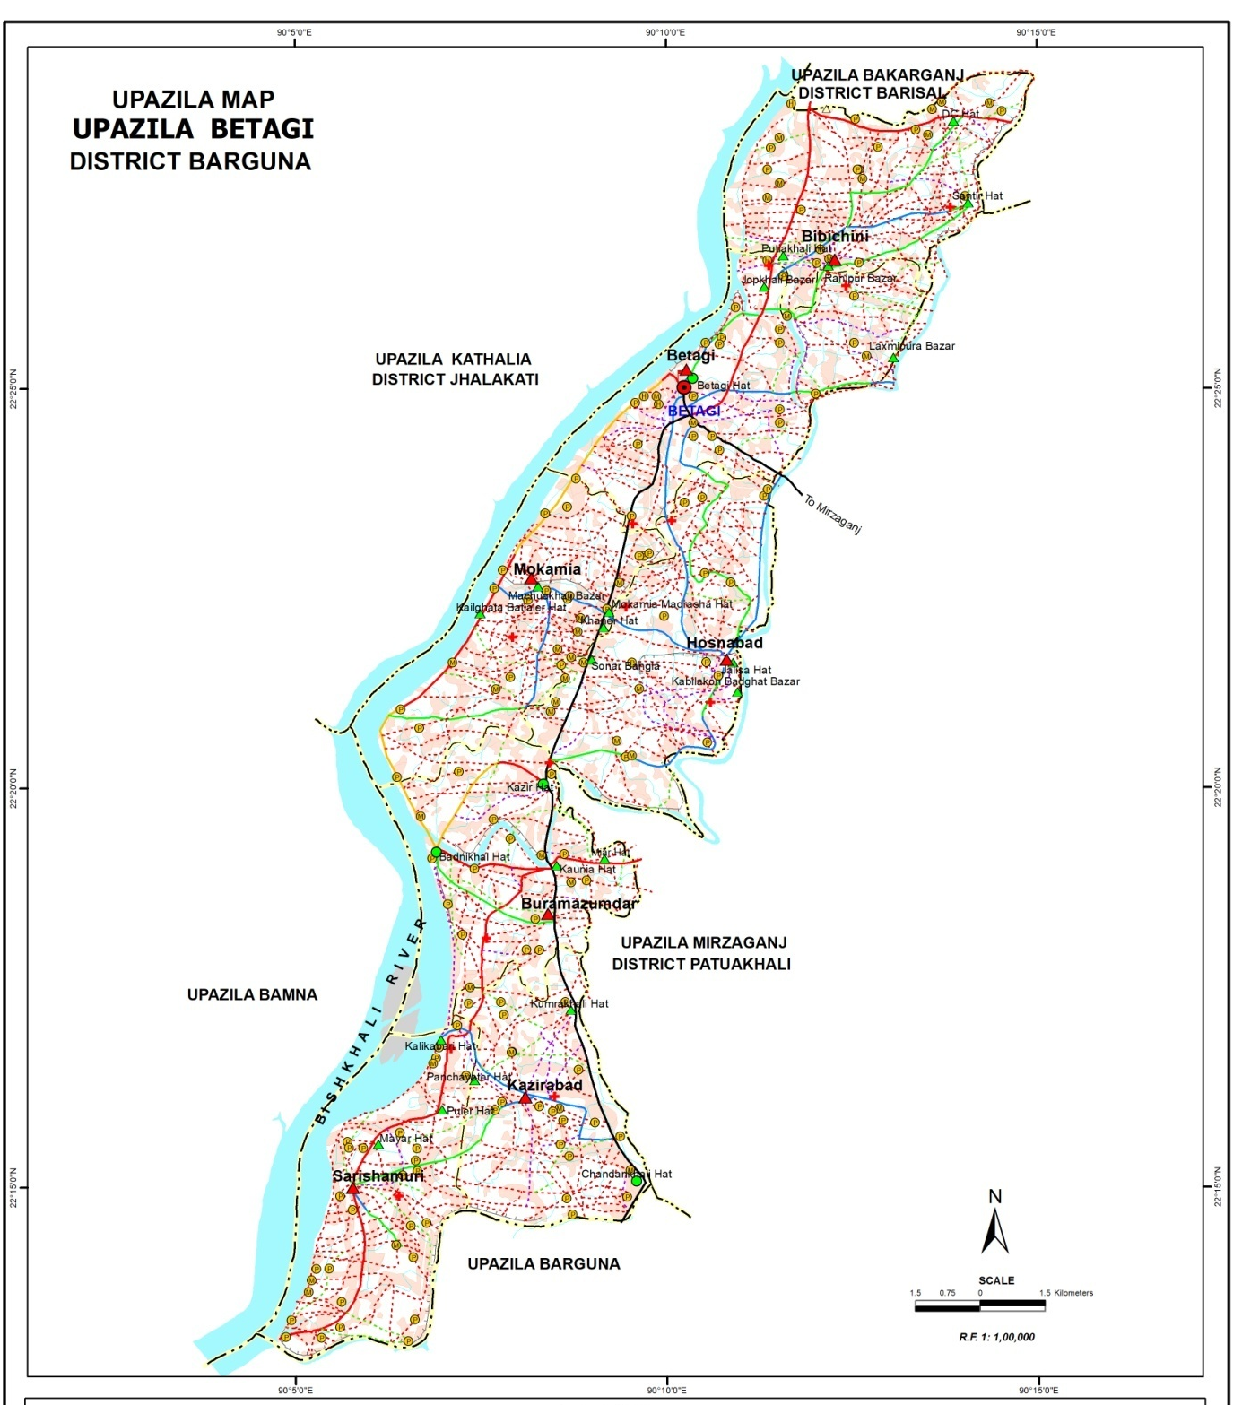
Proposed Poura Super Market

Map 2: Location map of proposed Poura Super Market

Layout of the Subproject
The layout plan of the proposed Super Market is given as below:

Layout Plan: The layout plan of the proposed Poura Super Market

Ownership of the Subproject’s Land
Betagi Pourashava is the legal owner of the proposed land where the Super Market will be constructed. No land acquisition is required.

Present Condition of the Proposed Subproject’s Site
The proposed subproject site is owned by the Betagi Pourashava and there is an existing damaged semi-pucca tin-shed. There are no trees in the proposed sub-project site. The total area of the land of the proposed Super market is 966.54sq.m. It is surrounded by shops at the north and the south; roads at the east and west side. The presentation condition of different portion of the proposed site is depicted in Picture 1, Picture2, Picture 3 and Picture 4.

Picture 1: North side view of the site

Picture 2: South side view of the site

Picture 3: East side view of the site

Picture 4: West side view of the site

Key Activities of the Subproject
The activities to be carried out during preconstruction include:
- Dismantling of existing tin shed structures (2 nos.);
- Earth work for preparing the site for construction;
- Construction of the semi-pucca site office;
- Construction of semi-pucca labor sheds with separate latrine facilities for male and female workers;
- Construction of pucca platform for stocking construction materials; and
- Construction of temporary boundary wall around the labor shed and stockyard
The major activities to be carried out during the construction phase include:
- Construction of the superstructure and associated civil works;
- Electricity connection and other ancillary works;
- Provision of other supporting/ancillary facilities; and
- Workers’ health and safety issues.
The activities to be carried out and continued during operational phase include:
- Solid waste collection and disposal;
- Waste water collection, treatment and disposal;
- Traffic control; and
- Fire safety, natural disaster and risk management.

Category of the Subproject
Environmental Screening (ES) for the Super Market has been conducted with the purpose of fulfilling the requirements of Government of Bangladesh (GOB) and the World Bank (WB). Environmental Screening ensures that environmental issues are properly identified in terms of extent of negative and positive impacts. The environmental screening of the Super Market was done in consultation and active participation of different stakeholders including Pourashava Officials. The list of participants is attached as Annexure 1. Environmental Screening Checklist, as adopted in Appendix C of the Environmental Management Framework (EMF) of the MGSP, was administered for identifying the impacts and their extents.
- According to ECR 1997: Green □ Orange A □ Orange B □ √ Red □ Not Listed □
- According to WB classification: Category B □ √ Category C □
Considering the potential environmental impacts, construction of the Super market can be considered as Orange B as per ECR-97(Multistoried Commercial Building). According to the WB classification, it is of Category B.

Analysis of Alternatives
The analysis of alternative of the subproject is done from three main perspectives such as location, design and technology or method of construction. The analysis of alternative of the subproject is given as below:

- Analysis of alternative location
The objective of alternative analysis is to identify the suitable location for this proposed sub-project of construction of Betagi Supar Market that would generate the least adverse impact and maximize the positive impacts. According to capital investment plan (CIP) in 2018, Betagi Pourashava selected only this location as they have other no alternate vacant places where they can construct a Market. From the physical observation, it has been observed that the present location of the proposed “Poura stall” area is suitable for it’s connectivity, dwellers demand and absent of suitable market at nearest areas.
- Analysis of alternative design: A user-friendly design is required for constructing 3-storied Super Market at the selected location of the Pourashava. The steel framed structure is more resistant to earthquake and wind, but it is costly form of construction and construction is cumbersome. On the other hand, the RCC framed structure design is comparatively less resistant to earthquake and wind than steel frame structure but it is comparatively less costly form of construction is simple than steel frame structure. Considering the above issues, the RCC frame structure design is preferred by the Pourashava.
- Analysis of alternative technology or method of construction: The latest construction technologies, equipment and materials are comparatively costly but it is preferable for long-term use and multi-storied building. The simple technological methods are usually preferred for domestic construction and frequently available materials are mostly used. These are mostly low cost projects and are also short-term. As the proposed subproject will be a3-storied building with 3-storied foundation keeping the scope of extension in future, so the latest construction technologies, equipment and materials are desired. The technology to be used should not spoil the natural environment and materials to be used should be eco-friendly.
- No subproject scenario: If the proposed subproject i.e. 3-storied Super Market is not implemented, the community people as well as people from different part of the Betagi Pourashava and Betagi Upazila who purchase from this wholesale market will suffer a lot in case of getting and buying quality goods and products of daily needs. It will also limit the trades and businesses opportunities and facilities at the Pourashava area. Again, the sustainability of the Pourashava through increasing revenue and employment opportunity of the young people will be hampered if the subproject is not implemented. Therefore, it is required to construct the proposed subproject.
Conclusion: The construction of 3-storied Poura Super Market having 3-storied foundation with scope of future extension is then finally selected by the Betagi Pourashava.

Estimated Cost of the Subproject
The estimated cost of the proposed Supermarket is BDT 25 million.

Schedule of Implementation
The proposed subproject will be started on November 2018 and will be completed by the end of October 2019. Therefore, the subproject will be implemented within a period of 12 months.

BASELINE ANALYSIS OF ENVIRONMENTAL CONDITION

Physicochemical Environment

Important environmental features
Important environmental features in influence areas (100m around the subproject site) were observed through field observation. Detail observation and assessment were made on identified key environmental features like drainage congestion, waste water discharge, solid waste disposal and management, water contamination, air pollution, soil degradation, odor spreading and traffic movement etc. in and around the catchment or influenced areas of the subproject. Moreover, land use pattern of the influence areas was also observed and found human settlement, offices, commercial establishments, health care facilities, educational institutions, and water bodies as depicted in Table 4-1 as below. As an essential ingredient, an engineering and topographical survey was done that may need to be adjusted minor during the construction phase.
Table 4-1: Land use and important environmental features around the proposed Super Market
Sides/Direction | Important Environmental and Infrastructural Features
North | Road, 26 nos. Shop, Kali Mondir, Bishkhali River
West | Road, Electricity Supply Line, 152 Nos. Shop, Upazila Parishad Office, Zila Parishad Dakbanglo, Drain, Launch Terminal, Bishkhali River.
South | Road, 209 Nos. Shop, Khaskachari Math, Centra Shahid Minar, Saehin Alim Madrasha, ASA water Supply Plant, Kitchen Market, Girls High School & College, Baro Bridge, Etc.
East | Road, 41 Nos. Shop, Electricity Supply Line , Khal, 82 Nos. Shop, New Zila Parishad Dakbanglo(Under Construction), Betagi Govt. High School, Food Godawn, Puran Thana. Etc.

Transportation facilities, road network and traffic volume
According to the Master Plan and Pourashava sources, the Betagi Pourashava contains road and water way. There is one Launch Terminal at the north-western side of the Pourashava and about one kilometer (km) far from the Pourashava Office. The water way has mainly connected Betagi Pourashava with Barguna, Barisal and Dhaka City. According to the Pourashava sources, the length of the total road of the Pourashava is 65 km amongst which 20 km is bituminous carpeting road, 35 km is herringbone bond road and 10 km earthen road. Besides this the Pourashava has 20bridges/culverts. Both motorized and non-motorized vehicles are operated in all the roads of the Pourashava. According to key informant interviews (KII) and Pourashava sources, both motorized and non-motorized vehicles carries passengers and goods within and out of Pourashava. (Source: Betagi Pourashava, 2018)

Climate
The climate of the Betagi Pourashava is represented by the climate of Barguna district. Barguna has pronounced tropical climate and it has significant rainfall at most months, with a short dry season. In Barguna, the average annual temperature is 26.0 °C and the average annual rain fall is about 2,516 mm. With an average of 34.3 °C, May is the warmest month. At 13.3 °C on average, January is the coldest month of the year. The driest month is December with 10 mm of precipitation. In June, the rainfall reaches its peak, with an average of 571 mm. (Source: https://en.wikipedia.org/wiki/Barguna_District#Climate, dated on 30September 2018)

Topography and drainage
The Betagi Pourashava is mainly medium highland excepting some low lying strips including canals. Generally much of the Pourashava area is under agricultural area characterized by crop production. However, a significant portion of it is urbanized with scattered clusters.
The drainage network system of the Pourashava can be classified into three tiers such as primary drain and secondary drain. The primary drainage system comprises the natural khals/canals. The secondary drainage system consists of large open bricks or RCC drains, storm sewers, small canals and other structures which operate as intermediate mechanisms to deliver storm water from the tertiary drainage systems to the primary drainage system. The number of secondary drains in Betagi Pourashava is very few. The Betagi Pourashava has 1.18 km drainage network to discharge the run-off or storm water to natural drainage system. (Source: Master Plan 2011 and Pourashava Data, 2018)

Geology and soil
Bhola Island is part of the Ganges tidal floodplain (towards north) and the young Meghna estuarine floodplain (towards south) and is an active delta. In the Ganges tidal flood plain area, the sediments are mainly non-calcareous clays, but they are silty and slightly calcareous on riverbanks and in a transitional zone in the east adjoining the lower Meghna. In the young Meghna estuarine floodplain area, new deposition and erosion are constantly taking place on the margins, continuously altering the shape of the land areas. The sediments are deep silts, which are finally stratified and are slightly calcareous. In many, but not all parts, the soil surface becomes saline to varying degrees in the dry season.
basins. The soils are seasonally flooded, mainly by rain water, but all, except a few basins, soils become dry during the summer. The range from olive to dark grey in color and most are finely mottled, but mainly become acid when dry. Lower layers are mainly neutral to moderately alkaline in reaction with young tidal sediments and soils in the south and south-west are slightly calcareous and some are saline to vary degree. All soils appear to be rich in weather able minerals.

Hydrology and water resources
There are a numbers of khals within the Betagi Pourashava that drains out the storm and other water generated from households and commercial establishments. These khals are linked with Bay of Bengal through Bishkhali River.
Air quality and dust
The Betagi Pourashava is the main town of Betagi Upazila and very limited activities are performed inside the Poura areas. The bazar and the market places remain over crowded on hat days. The profile of the Pourashavais mainly urban area, which has mix of semi-densely settlements and commercial areas. There are only auto rickshaw move around the adjacent places of Betagi Upazila. Limited number of Buses move to other districts from Betagi. During field visits, there is no major air pollution sources found in Betagi Pourashava.
Moreover, to evaluate the existing condition of air quality contractor will perform the air quality test prior to construction. Following Table 4-2 shows the Bangladesh National Ambient Air Quality Standard comparing the WHO Guideline standard.
Table 4-2: Bangladesh national ambient air quality standard comparing the WHO guideline standard
Parameter | Environmental Conservation Rules,1997 |  |  |  | WHO | Present status
 | microgram/m³
 | Industrial | Commercial and Mix use | Residential and Rural area | Sensitive area
SPM | 500 | 400 | 200 | 100 | -
PM 2.5 | 65 |  |  |  | 10
PM10 | 150 |  |  |  | 20
SO₂ | 120 | 110 | 80 | 30 | 20
NO₂ | 100 | 100 | 80 | 30 | 40
Pb | .5

Noise level
Betagi Pourashava is a mixed area of residential, administrative, and commercial establishments. Although, there are very much insignificant sources of noise from Vehicles as well as from any industry except loud speaker in some occasional period. The insignificant noisy areas are Betagi Bazar, Launch Terminals, and Upazila office area. As a part of the baseline study, noise level measurement was done at different locations inside and around the proposed Betagi PouraSuper market areas. The purpose of ambient noise level measurement is to determine sound intensity at the subproject locations. Noise level measurement was performed during daytime with a sound level meter. The 2-minute continuous noise level measurements were carried out at the selected locations in 'A' weighting and slow response mode with 1 sec interval, and the average noise levels (L_{ave}) as well as the maximum noise levels (L_{max}) were determined. Table 4-3 shows the summary of noise level measurements carried out in different locations in and around the study area during daytime. The table also shows the Bangladesh noise level standards for mixed areas during daytime.
Table 4-3: Noise level measurements during day time at the selected locations in and around of the market
Noise level measurement locations | GPS Co-ordinate | Day-time |  | Bangladesh standard for commercial place (dBA),L_{max}
 |  | Minimum Noise level (dBA),L_{min} | Maximum Noise level (dBA),L_{max}
Outside of market(North) | 22°25'03.0"N 90°09'52.1"E | 63.20 | 77.1 | 70
Outside of market (South) | 22°25'01.7"N 90°09'53.4"E | 58.0 | 78.0 | 70
Outside of market(East) | 22°25'02.5"N 90°09'52.5"E | 53.20 | 73.8 | 70
Outside of market(West) | 22°25'00.8"N 90°09'52.9"E | 63.70 | 75.1 | 70

Source: Field Survey, September 2018

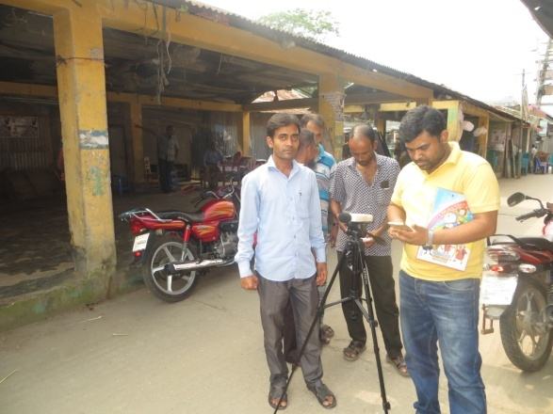

Water Quality
The surface water of pond and khals in the Pourashava are saline as it is very close to river Bishkhali. The present pollution level of the Pourashava areas is found to be low except coliform bacteria. The main causes of surface water pollution are waste water, sanitary sewage and solid waste dumping. Due to the present development trend of the Pourashava, the surface water pollution level of the areas may further increase for high volume of discharge of waste water, sanitary sewage, over spoils of pit and septic tanks, surface run-off of katcha bazars, and indiscriminate dumping of solid and medical wastes.
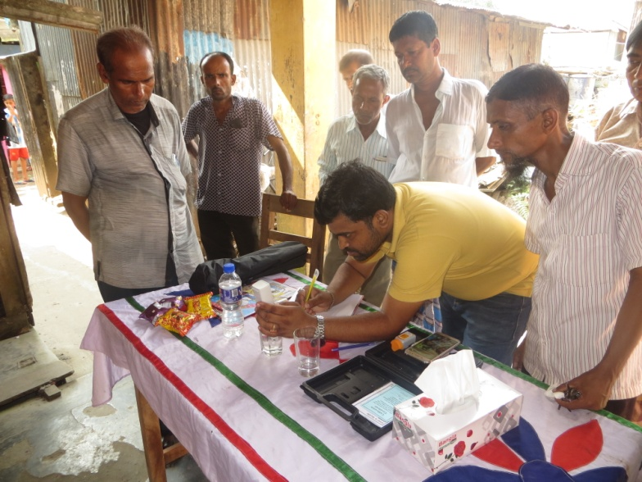

The result of recent water quality parameters of both surface water and ground water is given in Table 4-4 as below:
Table 4-4: The results of water quality parameters of both surface water and ground water at Betagi Pourashava
Sl # | Water quality parameters | Bangladesh Standard | Concentration present |  | Unit | Analysis method | LOQ
 |  |  | SPW | GW
01 | Arsenic (As) | 0.05 | <LOQ | <LOQ | mg/L | AAS | 0.0001
02 | Salt |  | 177 | 730 | mg/L | Multimeter | -
03 | TDS | 1000 | 198 | 155 | mg/L | Multimeter | -
04 | pH | 6.5-8.5 | 7.59 | 7.90 | - | Multimeter | -
Source: Field Survey, September 2018 & DPDC, BARGUNA

The urban dwellers of the Pourashava mainly depend on Ground Water. The ground water extracts by the Pourashava by deep production well and supplied by pipe water supply system after treatment in Water Treatment Plants. In some cases people install shallow hand tube well for fulfilling their domestic requirements.

Biological Environment

Floral habitat and diversity (terrestrial and aquatic)
The plant life is confined generally to variations belonging to the lower gangetic plane and of other districts in the southern region of the country.There is no organized forestry in the Betagi. However, all homesteads are usually covered by dense and lush green foliage of wide variety of trees. In the farmlands varieties of crops namely local Hybrid and HYV rice, jute, vegetables, spices, pulses, oilseeds, etc. are produced.
Most of the trees grown in homestead forests are fruits bearing. Mangoes, although poor in quality, grow in abundance. Almond or badam (Arachis hypogea) grow in unusually. Other common trees are gab (Dioaspyrosprecatorius), jack fruit (Artocarpusheterophyllus), black berry (Syzygiumcumini), tamarind (Tamarindusindica), jalpai (Elaeocarpustectorius), bel (aeglemarmelos), chalta (Dilleniaindica), boroi, guava (Psidiumguagava), etc. banana (Banana musasapientum) is seen almost everywhere but their quality is rather poor. Litchi (Litchi chinensis), Kamranga (Averrhokarmbola), ata, haritaki (Marketiachebula), amloki (Phyllanthusemblica), etc. grow abundantly. Indigenous timber trees include koroi, sheelkoroi(Albiziaprocera). garjan(Dipterocarpusturbinatus), jarul (Iegerstroemiaspeciosa), shimul (Bombaxceiba), etc. however, various exotic trees like teak, mahagoni (Swieteniamacrophylla), sissu (Dalbergiasissoo), etc. have been in produced as wayside trees as well as farm forestry.
The luxuriant growth of palms is the most characteristic feature of the vegetation. Supari (Areca catechu) plantations are more and more abundant towards the north and the west of the district and grows almost in forest. Cocoanuts are grown abundantly throughout the district. Toddy palms or tal (Borassusflabellifer) and date palms or khejur are also very common.
Shady trees include banyan or bat (Ficusbenghalensis), pipal(Ficusreligiosa) and nim
(Azadirachtaindica). There are several varieties of cane, a good deal of bamboo of different varieties and thatching grass or chhan although their plantations are gradually decreasing steadily.

Faunal habitat and diversity (terrestrial and aquatic)
Owing to the absence of organized forest and other natural conditions, any kind of large or medium carnivores are no longer seen in the district. However, the following mammals are still seen the district although their number is gradually decreasing: jackel(Canisaureus), fox (Vulpesbengalensis), large Indian civet or bagdas(Viverrazibetha), ottar or ud(Lutralutra), lrrawaddy, katbiral(Callosciuruspygerythrus), bengal mongoose or beji(herpestesedwards), different kind of rats and several species of bats.
Almost all varieties of birds that are seen all over Bangladesh are also commonly seen in Betagi. Many kinds of clourful and singing birds are seen in the district. These include the national bird robin magpie (Copsychussaularis), kokil(Cuculusmicroplerus), haldepakhi(Oriolus
xanthornus), kingcrow or finga(Dicrurnsadsimilis), myna (Sturnusmalabarica), shalik
(Acridotherestristis)), redvented bulbul (Pycnotuscafer), tuntuni(Orthotomussutorious), shama
(Copsyehusmalabaricus), sparrow (Passer domesticus), flowerpecker(Dicacumerythrochynchos),babui(Plocusphillippinus) famous for artistic nest building on the several species of pheasants quails (Eudynamisscolopscea), pigeons and doves.
The reptiles include different species of snakes, lizards and tortoises. The snakes include different varieties of cobra, urgabora, dughadabora, kuchiabora and jinlabora, all poisonous. The lizards include gecko, calotis, wall lizard and monitor lizard. There are amphibnians like toad, frogs and tree frogs.
There are many species of sea and fresh water fish available in the district. The list of the varieties is too long to find place in this volume. The popular varieties include the carp tribe (Cyprinidoes), ruhi(Labeorohita), katla(Catlacatla), mrigel(Cirrhinusmrigala) and kalabaush(labeocalbasu). airh (Mystusaor), tengra (Mystusvittatus) of several types, magur (Clariasbatrschus), singi (Saccobranchusfossilis) and koi (Mystusvittatus) are considered to be delicious, shoul(Channastriatus), boal(Wallagoattu), gazar(Channamarulius) and pabda (Ompokpabda) are available in abundance. Prawn, cry fish (icha) and crabs are also found muralla, punti, khoksha, bain and chela are small fish and are found all over the district in abundance.
Exotic fishes like grass carp (Cteopharyngodenidellus), silver carp (Hypophthalmicthysmolitrix),tilapia (Oreochromismossambicus), nilotica(Oreochromisniloticus), etc. have also been introduced for commercial pisciculture in ponds and tanks.

Socioeconomic Environment

Status of land use pattern, housing and built-up infrastructure
According to the Master Plan of the Pourashava, the major land use of the Betagi Pourashava goes to agriculture purpose and it is 37% of the total land. The second highest land use is peripheral areas and occupying 20.54% of the total areas.
According to the Population and Housing Census 2011, the highest percentage of general households by types of structures of the Pourashava is Semi Pucca (85.5%). The percentage of other general households by the types of structures of the Pourashava include 0.5% percent pucca households, 14.0% katcha households and 83.3%jhupri households among the non-structured households. In addition, the average household size of the Pourashava is 4.0.
There are also markets, bazars, shops, educational institutes, private and government offices, business establishments etc in the influence areas of the subproject.

Beneficiary population
All the people living in Betagi Pourashava will be benefited by the Super market. ‍Therefore, a total of 10204 people of the Pourashava will be benefited just after the construction of the Super market (Pourashava Data, 2018). Considering the current average growth rate of population in Betagi Pourashavaas 1.07 percent per year, the estimated number of the people of the Pourashava will be 12650 in 2031. All these people will be benefitted from the proposed Super market. In addition, a significant number of people who will be travelling from the different parts of Betagi Upazila through this Super market will also be benefitted.

Educational status
As per the Population and Housing Census 2011, the literacy rate among the both sex aged 7 years and above of Betagi Pourashava is 76.4. The literacy rate among the male is higher than the female. The literacy rate among the male is 79.4 whereas it is 73.4 among the female.
There are three colleges, four madrasa, two high schools, and six primary schools in Pourashava areas which are providing educational supports and services to the inhabitants in Pourashava areas.

Livelihood and economic situation
In Chowmuhani Pourashava, only 2.21% people are engaged in agricultural activities including farmers and laborers for their livelihood although 39.65% of the Pourashava area is under agriculture. Among the male income earner, over 24.65% are engaged in trading, 7.58% are working in private company, 2.06% are labor, 1.25% are in public services and 2.21% are day labor (agriculture).
The Pourashava is well known for industrial establishments in Noakhali region. Delta Jute Mills is the largest and oldest individual industry. The second largest industrial establishment is BSCIC. Besides, other small and processing establishments include Oil Mills (7), Printing Press (20), Rice Mills (40), Flour Mills (27), Ata Mills (15), Saw Mills, small scale factories etc.
The commercial activities of the Pourashava are dominated by both wholesale and retail business. The Pourashava is the largest wholesale market of the region. The major part of trade and commerce of the Pourashava is conducted through hat/bazar where agricultural produces, consumer items, merchandise for household and other farm and non-farm items are traded. The market/bazar performs significant role in the economy of the Pourashava.

Land acquisition and resettlement
The subproject site is situated on the land which is owned by Pourashava. Hence, land acquisition is not required.

Tribal communities
There is no indigenous or tribal people settlement in the subproject area. Therefore, there is no need to take any kind of protective measures for indigenous peoples’ safeguard.

Cultural heritage and protected areas
Within the influence area of the subproject, there is no protected area and no important historical sites identified during the field visit.

ENVIRONMENTAL SCREENING
Environmental Screening (ES) for the subproject have been conducted with the purpose of fulfilling the requirements of GOB and WB following the participatory approach. The list of participants who attended at environmental screening is attached as Annexure 1. ES ensures that environmental issues are properly identified in terms of extent of the impacts. Environmental Screening Checklist, as adopted in Appendix C of the Environmental Management Framework of the MGSP, was administered for identifying the impacts and their extents. The screening data and information those have been formulated for the Super Market are given as below:

5.1. Potential Environmental Impact during Construction Phase
(A) Ecological Impacts:
- Felling of trees : Significant □ Moderate □Minor □√
Number of trees : N/A
- Clearing of vegetation : significant□ Moderate □Minor □√
- Potential impact on aquatic species environment : Significant □ Moderate □Minor □√
The proposed Super Market will be constructed at the place where there is an existing one-storied tin-shed. There is no tree at the Super Market areas. There is no vegetation to be cleaned for constructing the Super Market.
(B) Physico-Chemical Impacts:
- Noise pollution : Significant □Moderate √□Insignificant□
- Air pollution : Significant □Moderate □Insignificant□√
- Drainage congestion : Very likely □Likely□Unlikely □√
- Water pollution : Significant □Moderate□Insignificant □√
- Solid waste pollution :Significant □Moderate □Insignificant □√
- Construction wastes : Significant □Moderate□Insignificant □√
- Water logging : Significant □Moderate □insignificant □√
The subproject will have temporary and localized negative impact on physico-chemical environment during constructionand operational phases due to the construction of super structure, movement of vehicles for carrying construction materials and equipment, and using of welding and drilling machine, winch machine, concrete mixer and vibrator machine etc. Hence, the anticipated impact on noise is considered as moderate. Construction activities such as transportation of sand, stones, brick cheeps etc may generate dust that may cause air pollution and anticipated impact of it is considered as minor. Construction activities need demolishing work thuswill generate solid wastes and temporary impact on drainage system may cause ifthe raw materials of the construction work fall dawn into the existing drainage system. There is minimum chance of water pollution as there is a large pond few meters far from the site. A minimum amount of household level solid waste may generate at the labor shed. But, as the Pourashava has solid waste management system in place and it will have no impact on the surrounding environment. Further, minimum amount of solid waste might be generated during the construction work and will have minimum impact due to construction waste. In addition, there is well constructed and functional drain around the proposed site which will ensure the removal of storm water and thus, reduce the chance of water logging. Primarily, the subproject will have no adverse impact on the other physicochemical components. Moreover, proper silencer and muffler are to be used in all categories of machineries to be used during construction period to avoid uneven sounds.
(C) Socio-Economic Impacts:
- Traffic congestion : √Likely □Unlikely □
- Health and safety : Significant □√Moderate □Insignificant □
- Impact on archaeological : Significant □ Moderate □Insignificant □√
- Impact on historical : Significant □ Moderate □ Insignificant □√
- Employment generation : Significant □ √Moderate □ Insignificant □
As the subproject is situated at the bazar area, the subproject will likely have temporary negative impact in traffic congestion due to transportation of the construction materials and equipment during construction phases. So, proper traffic management is required during construction phases. Hence, it is anticipated that the subproject activities will have moderate impact on the local traffic system. As the subproject site is surrounded by different markets and commercial establishments and demolishing of existing structures, mixing and carrying construction materials etcwork will be performed with the conventional equipment and skilled laborers. Hence, anticipated impact on health and safety is considered as moderate. In addition, in case of any accident such as falling from the height during brick work, plastering work, painting work, glass fitting work etc. may cause severe impact on health and safety. So, the use of personal protection equipment will be ensured that will minimize the impact. There is no archaeological and historical site within the influence area. Further, it has moderate positive impact by generating employment opportunity for the local people as labors for construction of works will be hired locally and there is a chance of installing different kind of shops, restaurants etc around the subproject site will also expedite the employment generation at the subproject influence areas.

Potential Environmental Impact during Operational Phase
(A) Ecological Impacts:
- Potential impact on species of aquatic : Significant □ Moderate □Minor □√
During operational phase, the subproject activities will not have any likely impacts on the surrounding ecological environment. The Super Market will have a system to reserve black water in underground reserve tank and provision of vacuum cleaner to remove this water. Moreover, there will be a well-constructed drainage system surrounding the subproject site and connected with a khal through which the grey water to be generated at the market will be discharged into running river Meghna. It will reduce the impact on aquatic species.
(B) Physico-Chemical Impacts:
- Potential air quality & noise level : Improvement □No-improvement□ √Deterioration □
- Drainage congestion : Improvement □ Minor Improvement □No Impact □√
- Risk of water pollution : Significant □Moderate□ Minor □√
- Pollution from solid waste : Improvement □No-improvement□√Deterioration □
During operational phase, there is no possibility to deteriorate the air quality as no dust and emission of carbon-dioxide will be generated from the proposed subproject but noise pollution due to public gathering at the market area may create moderate noise nuisance. However, proper management of solid waste using waste bins, collecting waste from bins and disposal of waste at landfill, and regular cleaning and maintenance of drainage system to be ensured during operational phase. If the waste bins are not used properly at different places of the market and organic wastes are thrown here and there, it may pollute the surrounding environment.
(C) Socio-Economic Impacts:
- Traffic :Improvement□ No-improvement√□ Adverse□
- Safety : Improvement□ √ No-improvement□ Adverse □
- Employment generation :Significant □√ Moderate □ Minor □
The proposed Super Market will have a provision of proper traffic management in place which will have significant positive impact on reducing traffic congestion at the market area as well as surrounding areas. However, it may create traffic congestion due to improper parking of the vehicles and ignoring of the traffic rules. So, proper traffic management plan is required during operational phase. In addition, the market will have a provision of proper security system with CCTV camera in and around the market premises which will improve the security and safety of shop keepers, customers and traders. However, during operational phase, possible accidents and social risks due to causalities at the market, fire hazard, short-circuit and other vulnerability may also have negative socio-economic impacts. The Super Market will have significant positive impact by providing job and business facilities and resource mobility. There is a provision of establishing different types of shops at the market which will create employment opportunity for the local young people.

Summary of Possible Environmental Impacts of the Subproject
The ecological impact is not significant due to the construction activities but there will be some impacts on the physico-chemical parameter of environment during construction period. Demolishing of existing structures and construction works may temporarily increase noise and air pollution at the surrounding environment and may create localized hazards. Demolition work will generate huge construction water which needs to be disposed properly. Otherwise, it will create drainage congestions at the surrounding areas. It may also cause health and safety issues of the workers and shopkeepers at surrounding commercial establishments that demands necessary precautions. The anticipated impact on physicochemical components is mainly site specific and will be within the market boundary.
During operational phase, the solid wastes generation from the market should be handled and disposed-off properly by placing waste bins inside the market. The removing of waste water and fecal sludge through functional septic tank, soak pit and drainage system should be ensured. This subproject has positive impacts in terms of the generation of the employment opportunities due to construction activities, supplying of the materials at construction phase and by providing business facilities at operation phase.

IDENTIFICATION OF MAJOR SUBPROJECT ACTIVITIES

Major Activities during Pre-Construction Phase
The proposed subproject will be implemented at the vacant land. Thus, some pre-construction activities will be carried out for preparing the site ready for proposed construction activities. The major pre-construction activities to be carried out are as below:
- Demolition of existing structures;
- Earth work for preparing the site for construction;
- Construction of temporary separate labor sheds for men and women;
- Construction of separate toilet facilities for men and women labors;
- Providing temporary electric and water supply lines at the labor shed;
- Construction of temporary office for supervision of construction activities.

Major Activities during Construction Phase
During the construction phase, following major subproject activities to be carried out:
- Layout and cast in-situ RCC piling works where necessary;
- Earthwork and excavation for RCC pile cap, grade beam and Column;
- Construction of multi storied building with associated civil works;
- Construction of separate toilets for male and female inside the building;
- Construction of car parking site and road pavement for vehicles and customers;
- Construction of water tank, septic tank and soakage well;
- Construction of solar energy facilities;
- Electricity connection and other ancillary works;
- Provision for workers’ health and safety.

Major Activities during Operational Phase
The major activities to be considered during operational phase are as below:
- Collection and disposal of solid waste;
- Management of waste water and its treatment;
- Maintenance of drainage system;
- Traffic control;
- Safety and security mechanism.

ASSESSMENT OF ENVIORMENTAL IMPACTS AND ITS MITIGATION & ENHANCEMENT MEASURES

Potential Significant Environmental Impacts and Its Mitigation & Enhancement Measures during Pre-Construction Phase

Impact due to demolished works
The proposed subproject will replace tin-shed by the multi-storied new building which requires the demolition of existing structure. The demolition works need simple procedure and manual equipment like; hammer, mechanical drill machine, steel cutter etc. Though the demolition work is not massive and the impact will not be severe, but the demolition materials shall be managed properly. The materials like bricks, shutter, reinforcement, wooden doors, windows etc. are to be reused and the wastes and debris shall be disposed properly. During demolition of structures, the creation of dust and noise will be there and will have an impact on workers and community people living at adjacent areas.
To avoid or reduce the environmental impacts of the demolition works, following measures should be taken:
- Site should be fenced to protect from strong winds and to contain dust;
- Electric power and services shall be cut off before the starting of demolition works;
- Demolition work is to be started from roof and then side brick wall;
- No demolition works should be done at night to avoid noise pollution;
- No wastes materials and debris shall be burned on the site;
- No encroachment of adjacent road and private property by the debris;
- Water will be sprayed to control the dust to be generated during demolition;
- Ensure re-use of the materials and disposal of the wastes to landfill area;
- Demolished waste material should be transported through truck covered by tarpaulin; and
- Proper safety measures should be taken by the worker to avoid unwanted accidents

Impact due to labor camp and its sanitary latrine
Two separate labor camps, one for male and another for female will be constructed at the site before starting the construction activities. If the labor camps are not constructed with minimum raised platform and not cleaned properly, that will create health hazard to the laborers. Two temporary sanitary latrines, one for male and another for female will also be installed. Improper sanitary facilities may cause health hazards to the laborers and that may reduce the work efficiency. There is functional storm water drainage system all around the proposed site for labor shed that will facilitate easy surface run off. Following measures should be taken to avoid or minimize the health hazard:
- Two labor camps with raised platform should be constructed at the separate sides of the site with separate toilet facilities to ensure the safety and security of female workers.
- The contractor will install separate sanitary latrines for male and female workers. The latrines should have washing facilities (availability of water and soap).
- The labor shed shall be with the facilities like; mosquito nets, cooking arrangement, water supply, waste bins, lighting etc.
- A temporary drain for the waste water is to be provided and rain water drainage around the camp site is to be provided for easy surface runoff.

Potential Significant Environmental Impacts during Construction Phase

Pollution from the construction materials and equipment
A wide variety of construction materials and equipment will be used during construction which required to be dumped at the site. Construction spoils such as accidental leakage of the oil, grease, and fuel in equipment yards might have a significant hazard. Surface water and soil quality might be polluted from these contaminants. Dumping of construction material such as sand, brick chips, cement etc might have a significant impact on air quality. The people to be engaged for the construction activities may also impede the physical and human habitats of the area.
The impacts to be caused by construction materials and equipment can be avoided or minimized by adopting the following mitigation and enhancement measures:
- Safe transport, storage, and disposal of the construction materials, and the equipment have to be carried out in order to avoid the accidental spillage and loss;
- Raised platform (brick soling with neat cement finishing to keep the materials) shall be constructed prior to start working (to be included with environmental safeguard items in the bidding document).
- Leakage fuel and lubricants from equipment will be collected by separate container for reuse or safe disposal. So that it cannot be spread and pollute adjacent areas.
- The vehicles to be used for carrying construction materials should be covered by tarpaulin.

Impact due to solid waste disposal
There is a possibility to generate solid waste during construction works such as residues of mutter, concrete, slaughtering materials etc, and in the labor sheds and its Super. The improper solid waste management activities during construction period may block the local drains at both the construction site; labor shed areas and local environment.
The impacts to be caused due to solid waste generation can be avoided or minimized by adopting the following mitigation and enhancement measures:
- Within the construction site, a number of waste bins will have to be provided by the contractor; and
- The Contractor will be responsible to deposit the every generated waste in a safe place and that will be carried by conservancy unit of the Pourashava to the dumping yard or landfill site.

Impact due to labor camp and its sanitary latrine
Two separate labor camps, one for male and another for female will be constructed at the site before starting the construction activities. If the labor camps are not constructed with minimum raised platform and not cleaned properly, that will create health hazard to the laborers. Improper sanitary facilities may cause health hazards to the laborers and that may reduce the work efficiency.
The impacts to be caused due to labor camps and its sanitary latrine can be avoided or minimized by adopting the following mitigation and enhancement measures:
- Two labor camps with raised platform should be constructed at the separate sides of the site with separate toilet facilities to ensure the safety and security of female workers.
- The contractor will install separate sanitary latrines for male and female workers. The latrines should have washing facilities (availability of water and soap).
- The labor shed shall be with the facilities like; mosquito nets, cooking arrangement, water supply, waste bins, lighting etc.
- A temporary drain for the waste water is to be provided and rain water drainage around the camp site is to be provided for easy surface runoff.

Impact due to inadequate drinking water supply
Safe drinking water supply is important for the construction workers such as labors, engineers, supervisors during construction work. If sufficient drinking water is not supplied during construction, it may cause health damage to them.
The impacts to be caused due to inadequate drinking water supply can be avoided or minimized by adopting the following mitigation and enhancement measures:
- The contractor will install tube well or ensure pipe line water supply as considered in the BOQ (environmental safeguard component) prior to starting the construction works;
- The water quality will have to be tested for its quality judgment in a regular interval.

Planning for transportation before starting the construction work
During construction phase, some additional traffic will be accumulated for bringing the construction materials and equipment. This traffic may cause temporary congestion on the roads nearby subproject areas. It is anticipated that the subproject activities will not create any severe impact on the local traffic system, because movement of the vehicles and equipment will be only for a short time and as per requirement. The on-site subproject activities do not have any impact on the local traffic system during construction phase, because the works will be done in a confined area. However, during operational phase, improper and roadside parking may create localized traffic congestion.
The impacts to be caused due to transportation of vehicles to be used for construction works can be avoided or minimized by adopting following measures:
- Any materials required for construction should be transported at night time (within 10.00 pm – 6.00 am)to avoid local traffic congestion;
- Proper vehicle movement schedule should be maintained in consultation with local people;
- Unloading of materials should be done inside project areas;
- Traffic control manpower will be deputed during construction and operation period;
- Control sign should be provided to regulate traffic movement;
- Safety arrangement should be inserted in the safeguard cost in BOQ.

Impact due to earth work
The proposed multi-storied market construction work will be consisted of earth cutting, earth filling, land dressing and removal of unsuitable or any hazardous materials. Some areas have to excavate for pile cap, basement floor and septic tank construction. In addition, some areas need to be filled with soil. These works lead dust blowing, noise and vibration which may cause air pollution, noise pollution and discomfort to adjacent commercial areas includes pedestrians. All those including the excavation and trenching are hazardous nature of construction activities that involve soil removal. If proper measures are not taken it may cause damage to construction site infrastructures and other underground utilities, if any. Following measures should be taken to avoid or reduce the impacts:
- Earthwork activities should be done in dry season;
- Contactor should use proper sheet pile or shore pile during earth cutting or earth excavation works and that is to be included in the structural design;
- The contract should not be allowed to collect top soil to filling the low land. Local sand can be collected to fill in the low areas of the market;
- Water spray should be continued during work or day time to control dust spreading;
- Inspection of the trenches should be done at the start of each shift;
- Adequate safety barriers should be provided with clear visible signs to alert both drivers and pedestrians;
- Adequate light should be provided to the barriers and signs to make them clearly visible at night from a distance sufficient to respond;
- Temporary arrangement should be in place for pedestrian and vehicular traffic at site; and
- Excavated earth should be retained in safer places so that pedestrians can walk smoothly.

Clogging of water inside the construction site
During pile work storm water may clog inside the construction site. During foundation, basement etc. construction work, earth excavation is essential. This earth work may lead the chances of stagnation of storm water into the excavated pit resulting it as the mosquito breeding in the subproject area. Following measures should be taken to avoid or reduce the impacts:
- Earthworks should be done during dry season; and
- During pile, foundation, basement floor etc. work, temporary drainage system will have to be provided and should be connected with existing drainage system to run out the storm water. If necessary, a submergible pump should be there to pump out the water inside the pit.

Clogging of local drain water
There is a possibility to clog the local drain with construction materials kept at the subproject site as there is an open storm drain at the south side of the Super market.
The impacts to be caused due to clogging of local drain water can be avoided or minimized by adopting the following mitigation and enhancement measures:
- Construction materials should be kept within a corner of construction area;
- Contractor will ensure proper disposal of construction wastes and that should not be disposed to the local drains.

Impact on air quality due to dust and emission of carbon dioxide
Different construction activities such as pile diving & casting, machinery movement, handling of construction materials (stone/brick chips, sand, and cement), rod fabrication, movement of trucks with construction materials etc. may generate dust and damage the air quality. The air quality in the area can be affected by emission of carbon dioxide of the construction trucks and other equipment that uses gasoline, and the unpleasant smell of paint and thinners that will be used during painting. This might affect the health of the people passing by or living around and working within the area.
The impacts on air quality to be caused due to dust and emission of carbon dioxide can be avoided or minimized by adopting the following mitigation and enhancement measures:
- Water should be sprayed to control the dust at day time;
- The trimming activity using odorless paints should be minimized;
- The condition of combustion-engine powered machine should be maintained;
- Low-sulfur fuels should be employed;
- Construction material should be transported through truck covered by tarpaulin; and
- The condition of Air quality during construction period should be tested in laboratory.

Impact on noise level
Different activities during construction work such as movement of vehicles, concrete mixer machine and crushing bricks at site may generate a significant level of noise. Concrete casting, cutting of steel for reinforcement etc. may also cause noise hazard.
The impacts on noise level can be avoided or minimized by adopting the following mitigation and enhancement measures:
- Construction materials should be transported with scheduled time;
- All powered mechanical equipment and machinery should be fitted with noise abating gear such as mufflers for effective sound reducing device;
- The use of personal protective equipment like helmet, goggles, ear plug, gloves, safety boot etc. should be ensured;
- The crushing of bricks/ stones should not be allowed at the project site. Broken brick or stone chips should be collected from distanced source to the subproject site for construction purpose; and
- Separate batch plant might be used for concreting work (Ready Mix Concrete if available).

Impact on surface water quality
There is no water body adjacent to the subproject. However, there is a big pond at the South side of the site which is few meters far from the site. Dust to be produced during demolition, the small debris during excavation, slight amount of cement that will flow with the air, construction waste, pile waste, effluent from work camps, food wastes etc. can affect the quality of surface water of the nearby water sources. Improper storage of different construction supplies such as steel bars, fine sand, considerable gravel and alike will affect the quality of the run-off water that will run down on drainage areas. Following measures should be taken to avoid or reduce the impacts:
- Water should be sprayed to control the dust;
- Waste material in any form should not be thrown in water body or unspecified places;
- Proper construction management including waste management, training of operators and workers will be provided to avoid pollution of water bodies or nearby habitants; and
- Waste bins are to be provided at different location of working and living places.

Contingency planning for any uneven situation
There are so many unwanted happenings may occur during construction periods. Proper contingency planning is required for overcoming any unwanted situation, otherwise, that will hamper the progress of works. Asa precaution, proper contingency planning is essential for smooth progress.
In order to avoid or reduce the impact of any uneven situation, following contingency measures should be taken in advance as precaution:
- All the emergency telephone numbers of all the departments like Police station, fire service and civil defense, truck and bus stands, hospitals, clinics, etc. should be available at site;
- There should be standby transport facilities to deal any accidental case;
- There should be a provision for fast-aid box and emergency on-call physician.
- The storage of the construction materials should be done in such a way that it might not create obstacle for movement of vehicles and pedestrians.

Occupational health and safety
The occupational health and safety is an important issue for any construction activities. It primarily focuses on work equipment and protective gears to avoid or minimize the risks. The Contractor should give especial attention on workers’ health and safety during construction work. The most important risks associated with the construction activities are listed below:
- Risks of using of the machineries in motion such as steel cutter, glass cutter etc.;
- Risk of falling from the height during chipping, plastering work, painting work etc.;
- Risk from drop down of the materials from the height during chipping, plastering work, painting work etc.;
- Risk from mechanical failure of the equipment such as pile rig and winch machine;
- Risk from the traffic collision or accidents during operation of the equipment such as hydraulic excavator, steel cutter, pile rig, winch machine, welding machine, and vehicles movement for the transportation activities of the subproject;
- Risks from head loads for carrying soil, construction materials and construction equipment;
- Risk associated to the sudden bad weather working conditions such as storm, thunder storm and earth quake etc.
- Exposure to the sunlight- workers are being exposed to the sun for long hours;
- Exposure to the high temperature, and humidity for a long time resulting in dehydration;
- Contact with the hazardous substances and wastes pose risks of the infections and diseases.
The key salient features of the general requirements for the workers’ health and safety stated are presented in Table 7.1.
Table 7-1: General requirements for the workers’ health and safety
Issues | Requirements
Health and Hygiene | - Protection against dust and furnace by using of the nose masks and covering of the head and body;  - Laborers will use proper safety belts during work at high altitude  - Ensure availability and using proper PPE (helmet, gloves, safety glass, safety shoes etc.) of all workers during work.  - Provide construction workers with basic information on infectious diseases including HIV/AIDS  - Proper scaffolding should be made available during construction  - Proper disposal of the wastes and effluents;  - Introduce waste bins for the solid waste management system.
Safety and Fast Aid Box | - Using of the personal protective equipment (helmet, gloves, goggles, nose mask, safety boots);  - Precautions during work on or near machineries in motion;  - Head loads are prohibited;  - First aid facilities should be provided and maintained;  - The first aid kit should include adhesive bandages, regular strength pain medication, gauze, and low grade disinfectant.
Compensation for Accidents at Work | - Contractors will bear medical treatment costs. If any sever accidents such as loss of hands, legs or loss of working ability or any case of death needs compensation-(the amount of the compensation should be fixed considering the type of accidents).
Dust and Fumes | - For any dust, fumes, or other impurities likely to be injurious to the workers, effective measures shall be taken to prevent their accumulation and its inhalation by the workers.
Over-crowding | - No labor room should be over-crowded, the labor camp should be provide 15 ft x 30 for male and 12 ft x 15 ft for female workers.

Impact on local community
The construction of subproject can cause air pollution and noise pollution during construction phase due to blow of dust and emission of gases during vehicle movement, generation of high sound during using equipment for mixing etc that may affect shopkeepers and community people working and living at the adjacent markets and surrounding areas as well as customers coming at different commercial settings around the construction site. In addition, there might be a conflict with community people in any uncertain events.
Following measures should be taken to avoid or minimize the local community impacts:
- Shopkeepers, customers and community people should be oriented to use masks during their movement near construction site;
- Construction equipment and machineries should not be used at night;
- Orientation and training will be provided to the contractors, supervisors and workers, on health, safety and environment including sexual diseases control (as of BOQ);
- Liaison with the communities will be maintained throughout the construction phase;
- Grievance redress mechanism has been established at the sub-project site.
- A detail disclosure on sub-project to be hanged at the visible side where community can see and read

Labor influx and anticipated impacts
The subproject has a positive impact on labor engagement since it will attract employment of local laborers. The most of the works will be done by the local laborers and there is very limited chance of engagement of outside laborers. So, the labor influx will beminimum in the construction of sub-project. There is a chance to avoid female workers from poor households to be employed in construction activities.
Following measures should be taken to avoid or minimize the impact on labor influx:
- Laborers from the local community should be employed in construction activities;
- Femalelaborers from poor households should be given highest priority to employ in construction activities.

Potential Significant Environmental Impacts and Its Mitigation and Enhancement Measures during Operational Phase

Air quality degradation
The emission of carbon dioxide of the cars to be used by the customers will be insignificant and there will be a parking place for the cars at the basement of the proposed subproject site which will avert the air pollution. However, unpleasant smell of paints and thinners that will be used during painting can affect the air quality. This might affect the health of the customers and shopkeepers of the Market.
The following mitigation and enhancement measures should be taken to minimize the air quality degradation:
- Avoid maximum speed movements in the site since this will make the dust go in the air;
- Odorless and lead free paints available in the market should be used;
- The condition of combustion-engine powered machine should be maintained.
- Low-sulfur fuels should be used

Noise pollution
The proposed subproject is situated at the Bazar areaof Betagi. Vehicles moving this area use hydraulic horns that create noise. The use of hydraulic horns by private cars at the parking place can also create noise pollution. In addition, overcrowded customers during peak-hours of marketing can create significant level of noise nuisance at the market place as well as at the nearby areas.
The following mitigation and enhancement measures should be taken to minimize the noise pollution:
- The traffic control authority should control the use of hydraulic horn in cars and minimize the traffic congestion at peak-hours at the parking place.

Solid wastes generation and disposal
Considering the nature of the sub- project, it is expected that a considerable volume of waste will be generated at the sub-project area.The lack of a suitable mechanism for proper disposal of this waste will lead to the development of breeding grounds for disease vectors, foul smells from decaying waste, drainage congestion and deterioration in the aesthetic value of the entire area.If these generated solid wastes are not disposed properly, it will also create unhygienic environment at the market and customers will feel discomfort.
The following mitigation and enhancement measures should be taken to ensure proper solid waste disposal and minimize its impact on environment:
- Adequate numbers of waste bins should be in place at market premises.
- Solid wastes to be generated at the market should be collected and disposed in selected landfill by the Pourashava Authority.

Traffic congestion
There is low possibility of traffic congestion in the front side of the market which is directly linked with Bazar Road. The proposed market will serve varieties of daily needs of the citizen of the Pourashava as well as people coming from different parts of the upazila. As a result, people will useauto-rickshaw, easy-bike, non-motorized rickshaw etc for transportation from and to the market. It may cause traffic congestion in the front side of the market. In addition, the small trucks or pick up those will be carrying goods to the market can cause traffic congestion.
The following mitigation and enhancement measures should be taken to minimize the impact of traffic congestions:
- Traffic police in consultation with Traffic Control Authority should be ensured at the cross-section in front of the market to ensure proper traffic management and to reduce traffic congestion.
- Local transportation vehicles should not be allowed to stay long time in front of the market.
- Direction/control sign for vehicle movement should be ensured in front of the market.

Accident due to fire hazard and electric short circuit
Fire hazard is a common threat to any establishments. Firing may occur due to negligenceand poor understanding ofsafety systems. Fire hazard may come from short circuit or open burning of waste material at the market.
The following mitigation and enhancement measures should be taken to minimize the accident due to fire hazard and electric short circuit:
- Fire extinguisher should be used and be placed at the stair-case site in every floor.
- Touching electrical appliances with wet hands should be prohibited with properly visible danger sign.
- Faulty or malfunctioning electrical products should not be used.
- Training should be provided to use firefighting equipment when necessary.
- Regularly checking and maintenance the electrical line of the market should be done.

Waste water disposal
Waste water will be generated from community toilets which will pollute adjacent environment if not properly cleaned and managed. It requires proper waste water collection, treatment and disposal facilities to minimize the water pollution.
Following measures should be taken to minimize the impacts:
- Separate sewer lines should be in place for waste water which will be generated at the market. Waste water tank could be constructed at the market and waste water should be collected by vacuum cleaner for proper disposal;
- Provision of soak pit is to be provided for the disposal of waste water to be generated. On the bottom of soak pit 1.5 m depth filter bed (Sylhet Sand and brick chips, 1:1 proportion) is preferable;
- The waste water, after filtration through the soak pit, will not be harmful either to ground water or to the nearby drains/ surface water; and
- The soak pit will have to be cleaned in a regular interval (at least in every three months).

Fecal sludge management
Fecal sludge will be generated from toilets to be used by customers and shop keepers of the proposed subproject. It will be managed through on-site sanitation system i.e. by constructing septic tank and soak pit. If the septic tank is not cleaned in regular interval, it can be overflowed and cause environmental pollution.
The following mitigation and enhancement measures should be taken to ensure proper fecal sludge management and minimize its impacts on environment:
- The Pourashava conservancy unit will clean the septic tanks in regular interval; and
- The collected fecal sludge must be transported to fecal sludge treatment plant by using a vacuum truck.

Impact on local community
The proposed subproject has a positive impact on the community people by creating business and employment opportunity during operational phase. The shops of the market will be allocated among the eligible community people of the Pourashava thus creating business opportunity to generate income. It will also create employment opportunity for young people by engaging them in shops to be operated. Local people including both male and female should be given emphasis in case of allocating shops of the market.

ENVIRONMENTAL MANAGEMENT PLAN
The objective of the environmental management plan (EMP) is to record environmental impacts resulting from the sub-project activities and to ensure implementation of the identified “mitigation measures”, in order to reduce adverse impacts and enhance positive impacts. Besides, it would also address any unexpected or unforeseen environmental impacts that may arise during construction and operational phases of the sub-projects.The identified environmental impacts and its mitigation and enhancement measures are given in Table 8-1 as below:

Environmental Management Plan (EMP) Matrix
The anticipated environmental impacts and corresponding mitigation and enhancement measures have been outlined in Table 8-1.

Table 8-1: EMP matrix of the proposed Super Market
Issues/ Environmental impact | Mitigation and enhancement measures to be taken | Location | Timing | Responsible organization
 |  |  |  | Implementation | Supervision/ Monitoring
Pre-construction phase
Construction vehicles and machinery | - Trial run of vehicles and machinery to be used to confirm that their conditions, level of emissions of pollutants and noise level will not cause serious damages to the surrounding environment. | At the construction site, or vehicle depot | Before the commencement of construction | Contractor | PIU of Betagi Pourashava and PMU of MGSP under BMDF
Impact due to demolition work | - Site should be fenced to protect from strong winds and to contain dust;  - Electric power and services shall be cut off before the starting of demolition works;  - Demolition work is to be started from roof and then side brick wall;  - No demolition works should be done at night to avoid noise pollution;  - No wastes materials and debris shall be burned on the site;  - No encroachment of adjacent road and private property by the debris;  - Water will be sprayed to control the dust to be generated during demolition;  - Ensure re-use of the materials and disposal of the wastes to landfill area;  - Demolished waste material should be transported through truck covered by tarpaulin;  - Proper safety measures should be taken by the worker to avoid unwanted accidents. | At the Construction site | During site preparation | Contractor | PIU of Betagi Pourashava and PMU of MGSP under BMDF
Air, water and noise quality laboratory test | - The base line condition of Air, Water and Noise quality of proposed Super market should be tested in laboratory | Proposed site | Pre-construction | Contractor | PIU of Betagi Pourashava and PMU of MGSP under BMDF
Construction phase
Pollution from the construction materials and equipment | - Safe transport, storage, and disposal of the construction materials, and the equipment have to be carried out in order to avoid the accidental spillage and loss;  - Raised platform (brick soling with neat cement finishing to keep the materials) shall be constructed prior to start working (to be included with environmental safeguard items in the bidding document).  - Leakage fuel and lubricants from equipment will be collected by separate container for reuse or safe disposal. So that it cannot be spread and pollute adjacent areas. | At the Construction site | During construction period | Contractor | PIU of Betagi Pourashava and PMU of MGSP under BMDF
Solid waste disposal | - Within the construction site, a number of waste bins will have to be provided by the contractor,  - The Contractor will be responsible to deposit the every generated waste in a safe place and that will be carried by conservancy unit of the Pourashava to the dumping yard or landfill site.  - Contactor will carry out the pile slurry to a safe place and that safe place shall be selected earlier (before pile diving). | At the Construction site | During construction period | Contractor | PIU of Betagi Pourashava and PMU of MGSP under BMDF
Labor camp and its Sanitary latrine | - Two labor camps with raised platform should be constructed at the separate sides of the site with separate toilet facilities to ensure the safety and security of female workers.  - The contractor will install separate sanitary latrines for male and female workers. The latrines should have washing facilities (availability of water and soap).  - The labor shed shall be with the facilities like; mosquito nets, cooking arrangement, water supply, waste bins, lighting etc.  - A temporary drain for the Super waste water is to be provided and rain water drainage around the camp site is to be provided for easy surface runoff. | At the Labor camp and construction site | During construction period | Contractor | PIU of Betagi Pourashava and PMU of MGSP under BMDF
Inadequate drinking water supply | - The contractor will install tube well or ensure pipe line water supply as considered in the BOQ (environmental safeguard component) prior to starting the construction works;  - The water quality will have to be tested for its quality judgment in a regular interval. | At the Labor camp and construction site | During construction period | Contractor | PIU of Betagi Pourashava and PMU of MGSP under BMDF
Transportation before starting construction works | - Any materials required for construction should be transported at night time (within 10.00 pm – 6.00 am) to avoid local traffic congestion;  - Proper vehicle movement schedule should be maintained in consultation with local people;  - Unloading of materials should be done inside project areas;  - Traffic control manpower will be deputed during construction and operation period;  - Control sign should be provided to regulate traffic movement;  - Safety arrangement should be inserted in the safeguard cost in BOQ. | At the Construction site | During construction period | Contractor | PIU of Betagi Pourashava and PMU of MGSP under BMDF
Earth work for construction works | - Earthwork activities should be done in dry season;  - Contactor should use proper sheet pile or shore pile during earth cutting or earth excavation works and that is to be included in the structural design;  - Water spray should be continued during work or day time to control dust spreading;  - Inspection of the trenches should be done at the start of each shift;  - Adequate safety barriers should be provided with clear visible signs to alert both drivers and pedestrians;  - Adequate light should be provided to the barriers and signs to make them clearly visible at night from a distance sufficient to respond;  - Temporary arrangement should be in place for pedestrian and vehicular traffic at site;  - Excavated earth should be retained in safer places so that pedestrian can walk smoothly. | At the Construction site | During construction period | Contractor | PIU of Betagi Pourashava and PMU of MGSP under BMDF
Clogging of water inside the construction site | - Earthworks should be done during dry season;  - During pile, foundation, basement floor etc. work, temporary drainage system will have to be provided and should be connected with existing drainage system to run out the storm water. If necessary, a submergible pump should be there to pump out the water inside the pit. | At the Construction site | During construction period | Contractor | PIU of Betagi Pourashava and PMU of MGSP under BMDF
Clogging of local drain water | - Construction materials should be kept within a corner of construction area;  - Contractor will ensure proper disposal of construction wastes and that should not be disposed to the local drains. | At the Construction site | During construction period | Contractor | PIU of Betagi Pourashava and PMU of MGSP under BMDF
Air quality due to dust and emission of carbon dioxide | - Water should be sprayed to control the dust at day time;  - The trimming activity using odorless paints should be minimized;  - The condition of combustion-engine powered machine should be maintained.  - Low-sulfur fuels should be employed;  - Construction material should be transported through truck covered by tarpaulin.  - The construction period condition of Air quality should be tested in laboratory. | At the Construction site and surrounding areas | During construction period | Contractor | PIU of Betagi Pourashava and PMU of MGSP under BMDF
Noise level | - Construction materials should be transported with scheduled time;  - All powered mechanical equipment and machinery should be fitted with noise abating gear such as mufflers for effective sound reducing device;  - The use of personal protective equipment like helmet, goggles, ear plug, gloves, safety boot etc. should be ensured;  - The crushing of bricks/ stones should not be allowed at the project site. Broken brick or stone chips should be collected from distanced source to the subproject site for construction purpose.  - Separate batch plant might be used for concreting work (Ready Mix Concrete if available). | At the Construction site and surrounding areas | During construction period | Contractor | PIU of Betagi Pourashava and PMU of MGSP under BMDF
Surface water quality | - Waste material in any form should not be thrown in storm drainage system;  - Proper construction management including waste management, training of operators and workers will be provided to avoid pollution of water bodies or nearby habitants.  - Waste bins are to be provided at different location of working and living places. | At the Construction site and surrounding areas | During construction period | Contractor | PIU of Betagi Pourashava and PMU of MGSP under BMDF
Uneven situation | - All the emergency telephone numbers of all the departments like Police station, fire service and civil defense, truck and bus stands, hospitals, clinics, etc. should be available at site;  - There should be standby transport facilities to deal any accidental case;  - There should be a provision for fast-aid box and emergency on-call physician.  - The storage of the construction materials should be done in such a way that it might not create obstacle for movement of vehicles and pedestrians. | At the Construction site and surrounding areas | During construction period | Contractor | PIU of Betagi Pourashava and PMU of MGSP under BMDF
Occupational health and safety | - Protection against dust and furnace by using of the nose masks and covering of the head and body;  - Labors will use proper safety belts during work at high altitude  - Ensure availability and using proper PPE (helmet, gloves, safety glass, safety shoes etc.) of all workers during work.  - Provide construction workers with basic information on infectious diseases including HIV/AIDS  - Proper scaffolding should be made available during construction  - Proper disposal of the wastes and effluents;  - Introduce waste bins for the solid waste management system.  - Using of the personal protective equipment (helmet, gloves, goggles, nose mask, safety boots);  - Precautions during work on or near machineries in motion;  - Head loads are prohibited;  - First aid facilities should be provided and maintained;  - The first aid kit should include adhesive bandages, regular strength pain medication, gauze, and low grade disinfectant.  - Contractors will bear medical treatment costs. If any sever accidents such as loss of hands, legs or loss of working ability or any case of death needs compensation-(the amount of the compensation should be fixed considering the type of accidents).  - For any dust, fumes, or other impurities likely to be injurious to the workers, effective measures shall be taken to prevent their accumulation and its inhalation by the workers.  - No labor room should be over-crowded, the labor camp should be provide 15 ft x 30 for male and 12 ft x 15 ft for female workers. | At the Construction site and surrounding areas | During construction period | Contractor | PIU of Betagi Pourashava and PMU of MGSP under BMDF
Impact on local community | - Community people should be oriented to use masks during their movement near construction site;  - Construction equipment and machineries should not be used at night.  - Orientation and training will be provided to the contractors, supervisors and workers, on health, safety and environment including sexual diseases control (as of BOQ),  - Liaison with the communities will be maintained throughout the construction phase.  - Grievance redress mechanism has been established at the sub-project site.  - A detail disclosure on sub-project to be hanged at the visible side where community can see and read. | At the Construction site and surrounding areas | During construction period | Contractor | PIU of Betagi Pourashava and PMU of MGSP under BMDF
Impact on labor influx | - Laborers from the local community should be employed in construction activities.  - Female laborers from poor households should be given highest priority to employ in construction activities. | At the Construction site | During construction period | Contractor | PIU of Betagi Pourashava and PMU of MGSP under BMDF
Operation phase
Air quality degradation | - Odorless paints available in the market should be used;  - Avoid any likely bad odor generated from the waste materials;  - Ensure effective solid waste management facilities.  - The operational phase condition of Air quality should be tested in laboratory. | At the market | During operational period | Market management committee | PIU of Betagi Pourashava
Noise pollution | - The traffic control authority should control the use of hydraulic horn in cars and minimize the traffic congestion at peak-hours at the parking place.  - The operational phase condition of noise level should be tested in laboratory. | At the market | During operational period | Market management committee | PIU of Betagi Pourashava
Solid wastes generation and disposal | - Sufficient numbers of waste bins should be in place at market premises.  - Solid wastes to be generated at the market should be collected and disposed in selected landfill. | At the market | During operational period | Market management committee | PIU of Betagi Pourashava
Traffic congestion | - Proper traffic control mechanism should be in place. | At the parking lot | During operational period | Market management committee | PIU of Betagi Pourashava
Accident due to fire hazard and electric short circuit | - Fire extinguisher should be used and be placed at the stair-case site in every floor.  - Touching electrical appliances with wet hands should be prohibited with properly visible danger sign.  - Faulty or malfunctioning electrical products should not be used.  - Training should be provided to use firefighting equipment when necessary.  - Regularly checking and maintenance the electrical line of the Super market should be done. | At the market | During operational period | Market management committee | PIU of Betagi Pourashava
Waste water, blood and other watery disposals | - Separate sewer lines should be in place for waste water to be generated at Super market;  - Provision of soak pit is to be provided for disposal of waste water to be generated. On the bottom of soak pit 1.5 m depth filter bed (Sylhet Sand and brick chips, 1:1 proportion) is preferable;  - The waste water, after filtration through the soak pit, will not be harmful either to ground water or to the nearby drains/ surface water.  - The soak pit will have to be cleaned in a regular interval (at least in every three months). | At the market | During operational period | Market Management Committee | PIU of Betagi Pourashava
Fecal sludge management | - The Pourashava’s conservancy unit will clean the septic tanks in regular interval;  - The collected fecal sludge must be transported to fecal sludge treatment plant by using a vacuum truck. | At the market | During operational period | Conservancy Unit of the Pourashava | PIU of Betagi Pourashava

Environmental Monitoring Plan
The Environmental Monitoring is important to record environmental impacts resulting from the subproject activities and to ensure implementation of the mitigation measures identified earlier in order to reduce adverse impacts and enhance positive impacts from the subproject activities. The environmental monitoring should be done at both constructional and operational phases.
Environmental monitoring requires a set of indicators that could be conveniently measured, assessed and evaluated periodically to observe the trends of change in base line environmental quality.
The following environmental monitoring plan should be adopted to monitor the activities of both construction and operational phases mentioned in the environmental management plan.

Monitoring during construction phase
The mitigation or enhancement measures outlines in EMP should be monitoring during construction period with regular interval in order to ensure its effective implementation to avoid the adverse effect of subproject activities and to gain the positive impacts resulting for the activities. The environmental monitoring plan during the construction period is given in Table 8-2 as below:
Table 8-2: Environmental Monitoring Plan during construction phase (visual observation)
Monitored Parameter/ Issues | Monitoring Method/ Key Aspects | Location of Monitoring | Frequency of Monitoring
Safety orientation and training of workers | Frequency of training & orientation of workers for safety | Subproject site | - Once in a month  - Reporting: Once in a month
Personal Protective Equipment | Ensure every single person involved in the activities wear and use safety equipment | Subproject site | - Daily  - Reporting: Once in a month
Worker’s health | Monitoring process of worker’s health | Subproject site | - Daily  - Reporting: Once in a month
Sanitation & drinking water facility to the workers | Availability of safe drinking water and sanitation to the workers | Subproject site | - Daily  - Reporting: Once in a month
Incident record and reporting | Documented record of all incident, accident, and its remedial process | Subproject site | - Daily  - Reporting: Once in a month
Site security/ Fencing at the site | Isolation of site from general access by fencing, restriction of the un-authorized entry in the site. | Subproject site | - Daily  - Reporting: Once in a month
Bulletin/ announcement boards/ prohibition signs | Visible in good condition or not | Subproject site | - Daily  - Reporting: Once in a month
Equipment /vehicles | -Switched-off diesel engines when not in use;  -Search any possible leakage;  -Fuelling. | Subproject site | - Daily  - Reporting: Once in a month
Solid waste generation | Quantity of solid wastes and disposal | Subproject site | - Daily  - Reporting: Once in a month
Gender equity | Direct survey in the field by interviews with the women in order to ensure that there is no any gaps between man and women | Subproject site | - Daily  - Reporting: Once in a month
Child labor | No child will be engaged in the activities | Subproject site | - Daily  - Reporting: Once in a month
Handling of hazardous materials | Fuelling, storage, operation | Subproject site | - Daily  - Reporting: Once in a month
The environmental parameters to be monitored during construction phases are given in Table 8-3 as below:
Table 8-3: Environmental parameters to be monitored (during construction phase)
Monitored Parameter / Issues | Monitoring Method/Key Aspects | Location of Monitoring | Period & Monitoring Frequency
Air quality (SPM, PM₁₀, and PM _{2.5}) | - Visually-black smoke;  - Sampling;  - Analysis at laboratory;  - analysis of merits determination by using quality standards;  - Through digital instruments. | Subproject site | - Two times during construction period;  - Reporting: Immediately after analysis and once in a month as a regular basis
Noise level | - Through digital noise level meter | Subproject site | - Two times during construction period;  - Reporting: Immediately after measurement and once in a month as a regular basis.
Water Quality | - Sampling;  - Analysis at laboratory;  - Analysis of merits determination by using quality standards;  - Through digital instruments | Subproject site | - Two times during construction period;  - Reporting: Immediately after measurement and once in a month as a regular basis.

Monitoring during operational phase
Environmental monitoring during operational phase is limited to a number of impact parameters to see the actual performance of the subproject. Monitoring of some issues might be necessary during the operational period of the subproject those are given in Table 8-4 as below.
Table 8-4: Environmental Monitoring plan during operational phase (visual observation)
SL No | Issue | Key aspects | Monitoring frequency per year
1 | Complaint from local people | Any significant complain from local people and it’s remedial procedure | 4
2 | Local drainage system | Maintaining proper drainage | 4
3 | Solid Waste Management | Proper management of solid wastes | 4
The environmental parameters to be monitored during operational phase are given in Table 8-5 as below:
Table 8-5: Environmental parameters to be monitored (monitoring frequency)
Parameter | Location | Monitoring frequency per year
Air quality (SPM, PM₁₀, and PM _{2.5}) | At the market areas | 2
Water quality ( BOD, pH, DO, TDS, Turbidity, NH₃) | At the nearby, surface water, ground water and drain water | 2
Noise and Vibration | At the market | 2

Grievance Redress Mechanism
The project-specific Grievance Redress Mechanism (GRM) will be established by the PIU of Betagi Pourashava to receive, evaluate, and facilitate the solution of affected people’s (Aps) concerns, complaints and grievances concerning the social and environmental performance of the subproject. The GRM is aimed to provide a time-bound and transparent mechanism to voice and resolve social and environmental concerns linked to the subproject.
The grievance mechanism is related to resolve the risks and adverse impacts of the subproject. It addresses APs’ concerns and complaints promptly, using an understandable and transparent process that is also gender responsive, and culturally appropriate. It is readily accessible to all segments of the affected people at no costs and without retribution. The mechanism should not impede access to the country’s judicial or administrative remedies. The affected people will be appropriately informed about the mechanism.
BMDF has its own Grievance Redress Procedure (GRP) and they operate it to address any dissatisfaction and complaints by the local people regarding its activities. This procedure is being applied to address any complaints or grievances through negotiations with the community leaders and representatives of the APs during implementation of the MGSP.

Grievance redress committee (GRC)
Betagi Pourashava has formed a Grievance Redress Committee (GRC) headed by The Mayor. With the facilitation of Consultant, the Mayor nominated the GRC members and included representative from the Government Agencies, local NGO, and Civil Society. The GRC will nominate a focal person. Complaints will be received through drop box, by post, email and website of Municipality. The grievance box will be set up at construction site to received complaints. The grievance response focal point will be available at the Municipality for recording the complaints and necessary response to an aggrieved person. It will receive complaints or suggestions, and produce them to the GRC for hearing and resolution. If any complaint is not resolved at Municipality level then the complaint will be produced to MD-BMDF. If it is not resolved by the MD-BMDF, then the subproject will be dropped.
The structure of the GRC and membership are given as below:
Chairman : ULB Mayor
Member-Secretary : Head of the Engineering Section of ULB
Member : Representative from local administration
: Teacher from a local educational institution
: Representative of a local NGO
: Representative of civil society
: Female ward councilor (of respective area)
The list of GRC members along with the notification from the Mayor is attached in Annexure 2.

Grievance resolution process
Given flow chart will be followed for grievance resolution process of this subproject.

WLCC
Drop Box
By Post
By Email
Website
Complaints and suggestions from communities and other stakeholder
ULB GRC
Suggestions and Complains designated for ULB GRC
GRM Books & Data Bank
Complaints resolved
And implemented
Unresolved Complaints referred to PMU, BMDF
Proceeding and decisions entered in GRM Books and in Databank
Subproject or its concerned component is dropped for cases
Unresolved at LGED/BMDF level
GRM Data Management / Reports
BMDF, PD (MD)
Independent Review and Evaluation
Public Dissemination via BMDF/ ULB Websites and printed reports

Flow diagram 8-1: Grievance resolution process
Note: If the appellant is still not satisfied, he or she has the right to take the case to the public courts. Betagi Pourashava should also publish the outcome of the cases on the public notice boards. All costs involved in resolving the complaints (meetings, consultations, communication, and information dissemination) will be borne by the Betagi Pourashava. The Municipality authority will try to resolve the issues (in most of the cases, in amicable settlement) within shortest possible time. However, the public court system is always open to resolve the issues.

Institutional Arrangement for Implementation of EMP
The Environmental Safeguard Compliance issues are directly vested the Municipality Officials; especially the Executive Engineer will be responsible for supporting the construction supervision with the facilitation of BMDF. The civil works contractors will implement the environmental mitigation measures.
The BMDF, with the help of Environmental Safeguard Specialist will submit the monthly monitoring reports on Environmental Compliances to the World Bank.
MD-BMDF

Environmental Safeguard Specialist-PMU

Social Safeguard Specialist-PMU

Executive Engineer of Municipality
PIU Focal Person for Environmental Safeguard
PIU Focal Person for Social Safeguard

Flow diagram 8-2: Institutional arrangement for implementation of EMP

Capacity Building
A two-day long training program in participation of PIU members of Betagi Pourashava was organized by the PMU of BMDF to build the capability of PIU of Betagi Pourashava. The Consultant, hired by the Betagi Pourashava also participated in the training program. The PMU of BMDF organized this training program in order to enhance their capacity to conduct Environmental Assessment and Social Impact Assessment to be done for any proposed subproject. A series of sessions were conducted by the Specialists of the PMU of BMDF. The major sessions includes: (i) Environmental Screening, (ii) EMP Implementation, including environmental monitoring requirements related to mitigation measures; and (iii) taking immediate action to remedy unexpected adverse impacts or ineffective mitigation measures found during the course of the implementation. The PIU of Betagi Pourashava will organized an orientation of contractor, workers and other support staff on environmental issues to be considered and mitigation measures to be taken during pre-construction, construction and operational phases before deploying to the work sites in order to achieve the expected standards.

Estimation of Environmental Safeguard Cost of EMP
Considering the environmental impacts and their mitigation measures for the subproject, several items are included in the BOQ for the environmental management. Table 8-6presents the estimated cost during construction phase and Table 8-7 presents the estimated cost during operation phase for the environmental management. Cost during construction phase will be included in BOQ but Cost during operation phase will be bearded by Betagi Pourashava.
Table 8-6: Environmental Management Budget during construction phase
Sl # | Description of the Items | Costs (in BDT)
1 | Establishment of labor camp (male shed - 15 ft x 30 ft and female shed 12 ft x 15 ft1) with living arrangement, drinking water facilities, cooking arrangement, mosquito net, waste bin etc. | 200,000.00
2 | Masonry pucca platform (at least 100 sft size), providing brick soling and net cement finishing for keeping fuel and lubricants for machineries. | 15,000.00
3 | Arrangement of temporary/ earthen drainage to drain out extra water logging due to rain and during construction works. All the temporary drains shall be filled up properly either at the end of event or at the end of works | 50,000.00
4 | Dust suppression measures by water spraying throughout the construction period in and around the subproject site, uncovered aggregates and loose materials such as stockpiles of the sands, excavated earth etc. | 90,000.00
5 | Air quality (SPM, PM₁₀, and PM _{2.5}) measurement- it can be measured from the recognized environmental survey company, public institute/ university one time before starting construction, three times during construction phase | 120,000.00
6 | Noise level measurement- it can be measured from the recognized environmental survey company, public institute/ university three times during construction phase and one time after construction | 30,000.00
7 | Water quality (pH, DO, TDS, BOD, Turbidity, NH₃)of market side drain and underground water measurement- it can be measured from the recognized environmental survey company, public institute/ university one time before starting the construction and three times during construction phase | 40,000
8 | Wastes disposal facility during the construction period; collection, transportation, and dumping of the wastes at landfill site and providing sufficient bins; at least 6 bins (500 litre size) to be provided. | 90,000.00
9 | Water supply facilities (for the labor shed and work site):1 no. of tube well (depending on the site condition the contractor will select the option) | 60,000.00
10 | Sanitation facilities (at the labor shed): 2 nos. of the toilets preferably portable toilets (1 no. for women and 1 no. for men) | 50,000.00
11 | Providing PPE like hand gloves, spectacles for eye protection, helmets, masks, visible jacket, ear plug, safety boots for at least 30 person  (25 for workers and 5 for visitor) and one first aid box with necessary medicine | 100,000.00
12 | Cautionary signs - 8 nos. | 15000.00
 | Total | 840,000.00

Table 8-7: Environmental Management Budget during operational phase (Annual)
Sl # | Description of the Items | Costs ( in BDT)
1 | Air quality (SPM, PM₁₀, and PM _{2.5}) measurement- it can be measured from the recognized environmental survey company, public institute/ university two times per year at operation | 60,000.00
2 | Noise level measurement- it can be measured from the recognized environmental survey company, public institute/ university two times per year at operation | 20000.00
3 | Water quality (pH, DO, TDS, BOD, Turbidity, NH₃) measurement. It can be measured from the pre-approved public institute/ university during operation period for waste water at underground water, drain and outfall @Tk. 10,000.00 per sample (2*3*5,000.00 Tk). | 30000.00
Note: The environmental safeguard compliance issues and cost (like solid waste management, water supply, traffic management, drain cleaning, test of environment parameter etc.) are to be done by the Market Management Committee and that is to be supervised by Betagi Pourashava.

COMPLIANCE WITH ENVIRONMENTAL CODE OF PRACTICES
The environmental code of practices (ECoPs) provides guidelines for environment management of the subprojects to be implemented in different urban local bodies (ULBs) under MGSP. The main objective of the ECoP is to manage construction operations in harmony with the environment in an effort to contribute to the well-being of the community and the environment by (i) minimizing pollution, (ii) sustaining eco-systems, (iii) conserving cultural heritage, and (iv) enhancing amenity. In compliance with ECoP, following issues associated with the proposed subproject are addressed during environmental assessment:
- Planning and design of the subproject;
- Site preparation;
- Construction camps;
- Waste management;
- Water bodies;
- Water quality;
- Drainage;
- Public health and safety;
- Material storage, transport and handling;
In this assessment, it is found that some of the issues are not relevant to this subproject. The issues those are found as relevant are addressed properly in this report to comply with the environmental code of practices as per the requirement of the MGSP.

PUBLIC CONSULTATION AND ACCESS TO INFORMATION

Introduction
Pubic Consultation is an effective tool for maintaining communication among the Municipality authority, BMDF as funding authority, different stakeholders of the subproject and community people where the subproject will be implemented. It helps to facilitate and streamline decision making as well as fosters an atmosphere of common understanding among individuals, group and organizations that could be affected or be affected by the subproject. It also ensures the transparency of the subproject at all levels of planning, design, construction and operation. It is a continuous process by which opinion from public is sought on matters affecting them. Hence, as a part of IEE/EIA, an effective public consultation and access to information is important.

Objectives
The main objectives of the public consultation and access to information under this subproject are: (i) to generate public awareness by providing information about the subproject to all stakeholders, particularly the subproject affected persons (PAPs) in a timely manner, and (ii) to provide opportunity to the stakeholders to raise their opinions and concerns on different aspects of the subproject.

Methodology
Public consultation about the planning, design, implementation and operation is done at different stages following different participatory methods. The methods followed in public consultation are: (1) consultative meeting with different stakeholders, (ii) Focus group discussion with community people through the participation of male participants, and (iii) Focus group discussion with community people through the participation of female participants, girls and boys, and disable people.
One consultative meeting was organized at community level through the participation of concern Councilor of Betagi Pourashava, traders, shopkeepers, local leaders, community elites and representatives of business men surrounding the market area. The participants were informed about the detail design and activities of subproject going to be implemented. Environmental screening of the subproject was also done in this meeting using the prescribed form mentioned in EMF of BMDF. They were asked to share their opinion, feedback and suggestions on environmental and social impacts of the subprojects as well as the mitigation measures to avoid or reduce the potential impacts.The list of participants of stakeholders’ meeting is attached as Annexure 3.

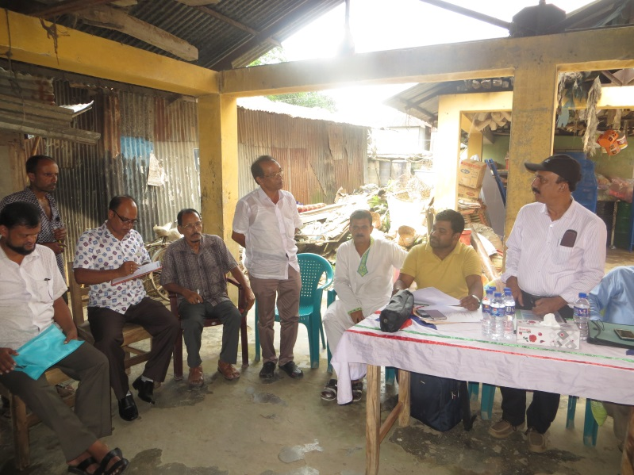
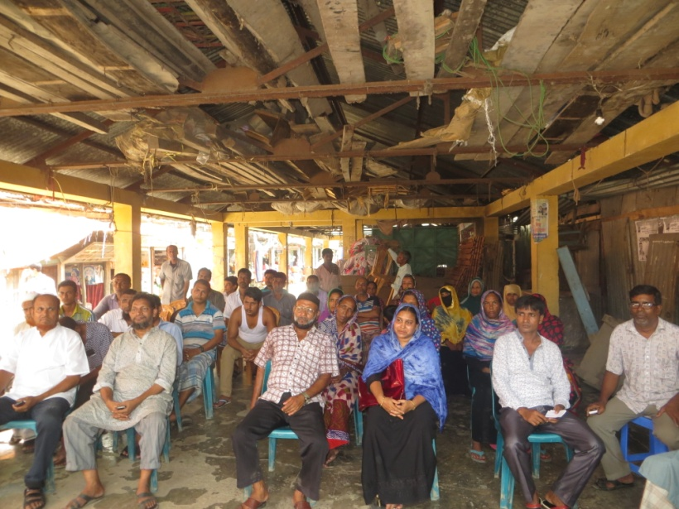
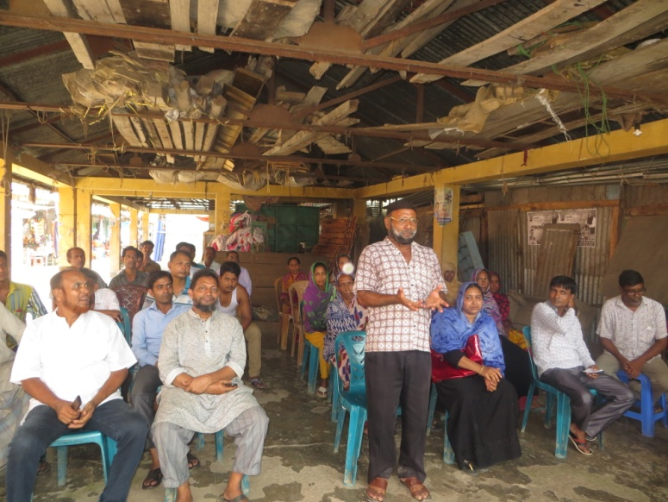
Picture 5: Participants at stakeholders’ meeting
One focus group discussion was organized with male community participants from different professions residing surrounding the subproject site. The participants were informed about the detail design and activities of subproject going to be implemented and asked about their opinion, feedback and suggestions on environmental and social impacts of the subprojects as well as the mitigation measures to avoid or reduce the potential impacts. The list of participants of FGD with male is attached as Annexure 4.
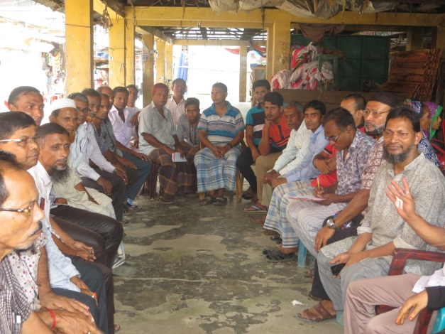
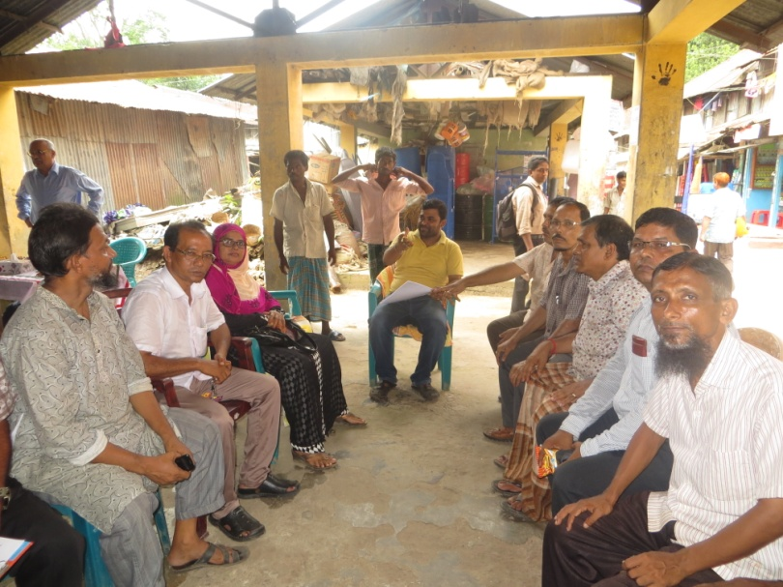
Picture 6: Participants of FGD with male group

Another focus group discussion was organized with female community participants came to the market and living around the subproject site. The participants were also informed about the detail design and activities of subproject going to be implemented and asked about their opinion, feedback and suggestions on environmental and social impacts of the subprojects as well as the mitigation measures to avoid or reduce the potential impacts on women’s point of view. In this session, boys and girls, and disable people were also present. The list of participants of FGD with female is attached as Annexure 5.
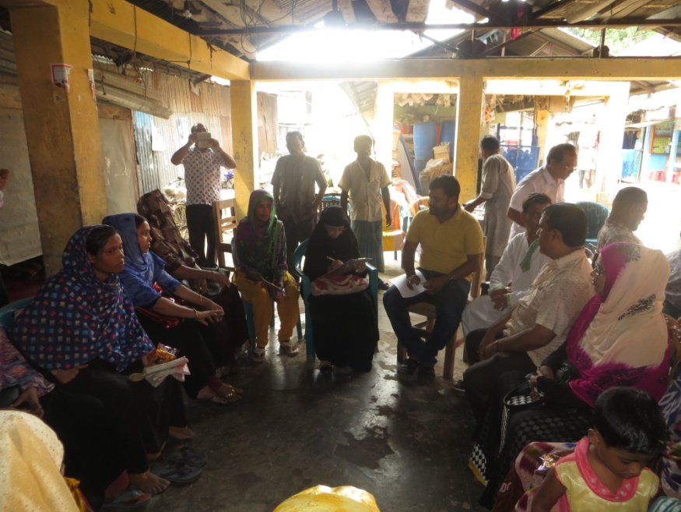
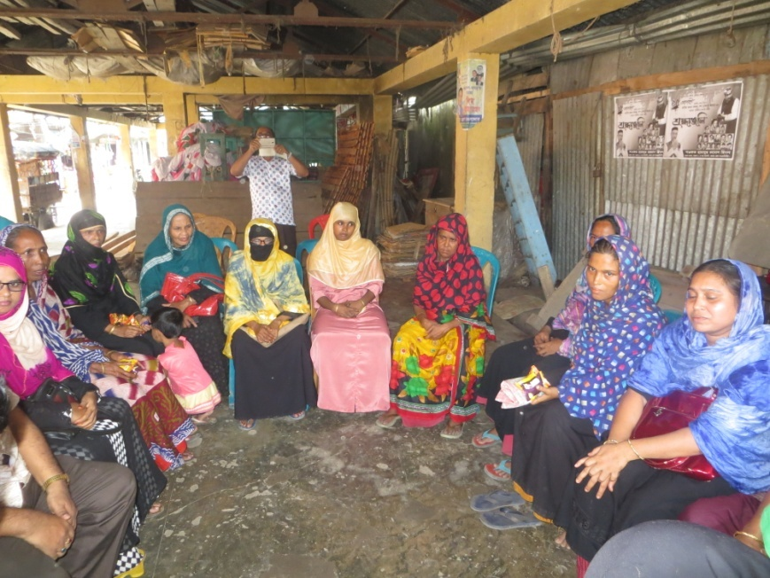
Picture 7: Participants of FGD with female group

Special efforts were made to include the elderly, women, and vulnerable groups and to allow them to express their views regarding the subproject implementation. In all cases, the impression of stakeholders and general mass regarding sub-project implementation was positive.

Issues Raised by the Participants
Following issues were raised during community consultation:
- Noise pollution due to the construction work;
- Protect the spreading of construction materials during construction work;
- Traffic congestion;
- Solid waste management;
- Social security; and
- Quality of construction work.

Feedback, Suggestions, and Recommendations of the Participants
Local people feltencouraged about the construction of Poura SuperMarket where varieties types of commodities will be available. In addition, it will create more business opportunities and employment scope for the local people especially for young people. They suggested making the market environment friendly considering and addressing all predicted adverse effects related to abovementioned issues with the implementation of potential mitigation and enhancement measures during both construction and operational phases. Participants requested the Municipality authority to maintain the quality of the construction work of the building. Adjacent community peoples of the proposed site and the shopkeepers of the adjacent commercial areas requested the Municipality authority to keep the noise level low and keep the construction work stopped after 10:00 pm at night, restrict the workers to visit adjacent areas, use quality construction materials, ensure proper traffic management and restrict the vehicles to enter into the narrow road, ensure proper solid waste management to be produced by the grocery and vegetable businessmen and customers, and honor the communities’ comfort and over tranquility of the environment.

Access to Information
The environmental assessment report should be translated into Bengali and disseminated locally. The copies of the report (both in English and Bengali) will be sent to all the concerned personnel responsible for subproject implementation. It will also be made available to the public. The final assessment report (both English and Bangla) will also be uploaded in the Betagi Pourashava website, BMDF website and the World Bank website after approval.

CONCLUSION AND RECOMMENDATIONS

Conclusion
On the basis of the findings of the environmental, it could be concluded that the subproject is environmentally sound and sustainable. The potential environmental impacts seem very minimum and manageable, and it would be minimized by taking proposed mitigation measures. The adverse environmental impacts from the subproject will mostly take place during the construction stage. No endangered or protected species of flora or fauna are reported at the subproject site.The benefits of the subproject will be significant by creating employment and business opportunities during the construction and operational phases. There is no significant cumulative adverse impact during operation that is identifiable at this stage. The proposed subproject activities have no significant adverse environmental impact so far as a time bound execution program with application of advanced construction technology is ensured. The mitigation measures are well within such codes and practices of construction and operation of the proposed subproject.

Recommendations
The attitude of the community people towards the vertical extension of Supercum municipal market with more facilities is positive as well as they have some recommendations to minimize some impacts of on the environmental and social environment during its construction and operation. The Government of Bangladesh and World Bank have some legal and social safeguard compliances issues those are applicable during constructing and operating the proposed subproject. Considering the above-mentioned issues and findings of the study, following key recommendations are made for smooth construction and successful operation of the Super market:
- Separate parking lot for private cars and goods carrying trucks should be established by the municipality maintaining a considerable distance from the market to avoid traffic congestion at the market area.
- A well-defined solid waste collection and disposal system should be in place at the market.
- All waste water should be discharged to the Municipal sewer system. In the absence of such system in the vicinity of the market, the septic tanks should be constructed.
- Fire prevention and fighting equipment should be provided and maintained as well as market management committee should be trained in fire prevention and fighting.
- The market should have facilities for washing, prayer, toilet, waiting, shopping, meals and snacks.
- Contractor will ensure availability of the PPEs and first-aid box, water supply and sanitation facilities to the workers.
- The surrounding people should be informed about the construction and operation of the Super market.
- Above all, the EMP should be followed and mitigation measures should be monitored as per EMP.

REFERENCES
- Bangladesh Bureau of Statistics. Bangladesh Population and Housing Census 2011. Community Report: Barguna.
- Bangladesh Bureau of Statistics. District Statistics 2011: Barguna.
- Bangladesh Municipal Development Fund. Environmental Management Framework, 2017.
- Betagi Pourashava Data, 2018.
- Betagi Pourashava. Master Plan of Betagi Pourashava, 2011.
- https://en.wikipedia.org/wiki/Barguna_District#Climate, dated on 28September 2018.

ANNEXURES

Annexure 1: List of participants attended at environmental screening exercise

Annexure 2: List of GRC members along with the notification from the Mayor

Annexure 3: List of participants attended in stakeholders’ meeting
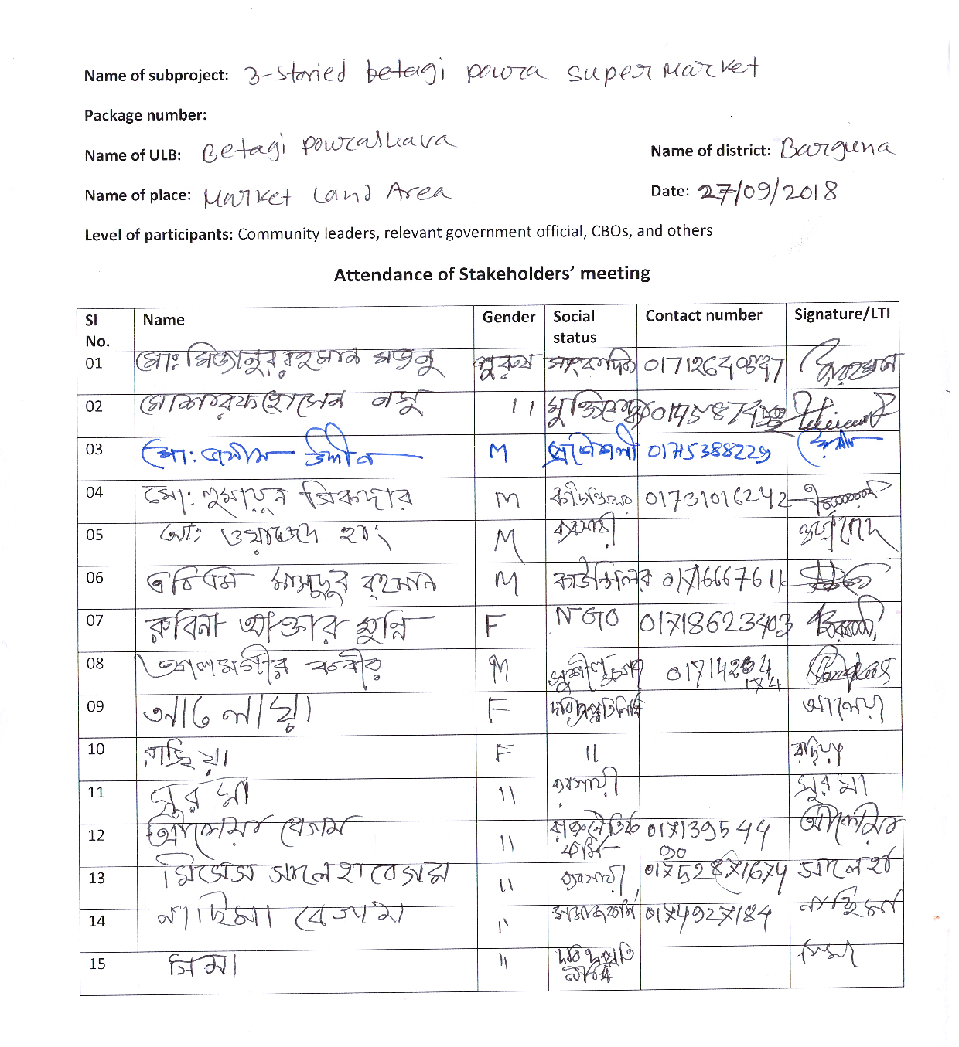
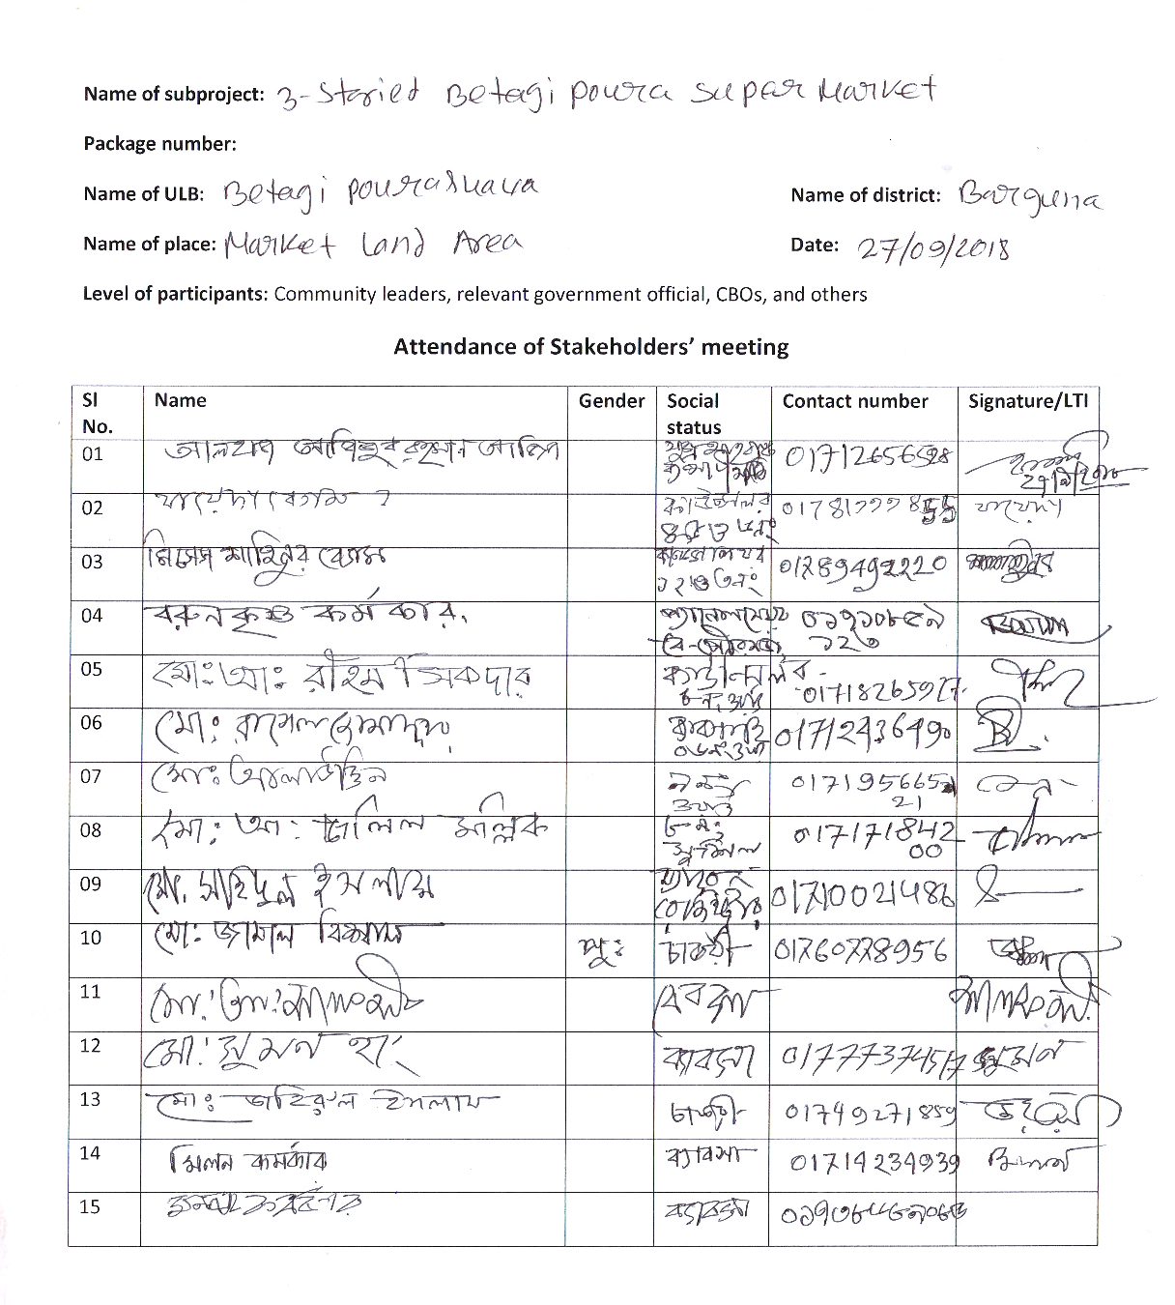
zer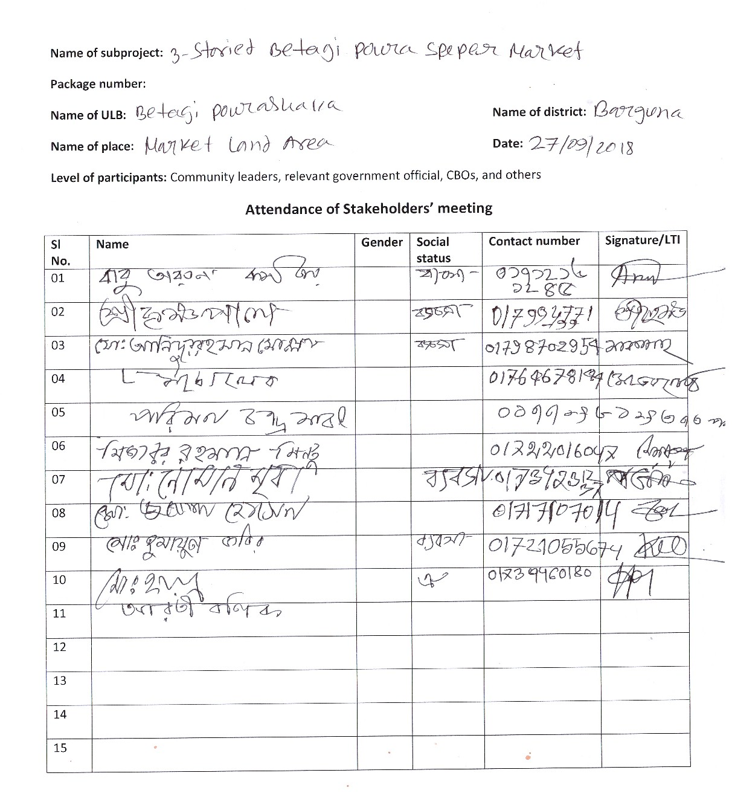

Annexure 4: List of participant attended in FGD with male group

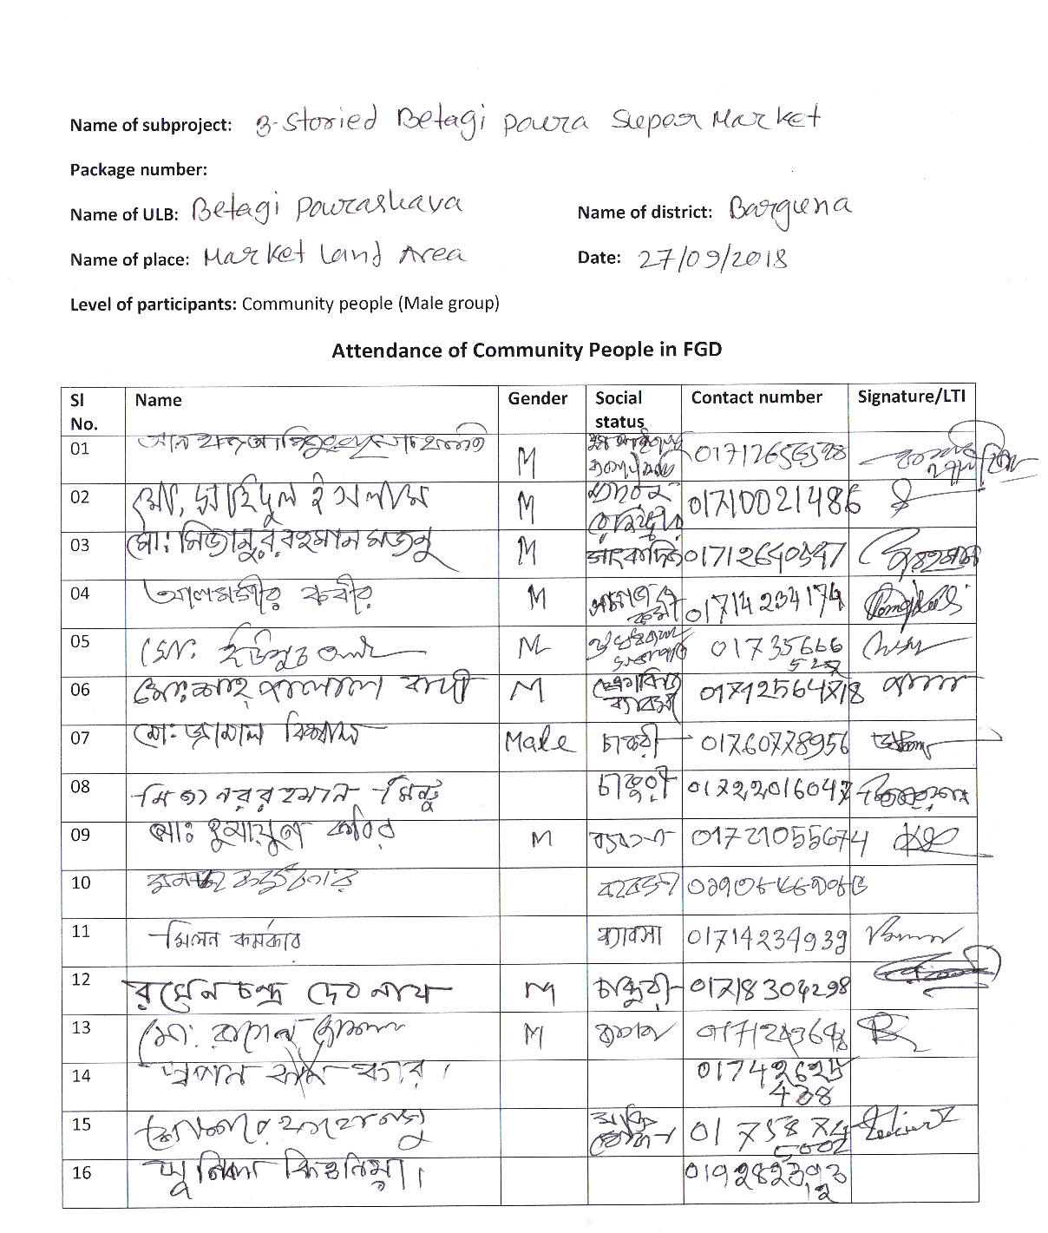

Annexure 5: List of participant attended in FGD with female group

